Data Analysis Practical
A practical introduction to using EpiInfo and LOGISTIC.EXE to analyse epidemiological data

January 2001, Mark Myatt

Variable names, types, and ranges

Background to the CATDAT.REC case-control study

A case-control study was conducted in Central India to assess pregnancy and childbirth related factors as possible risk factors for cataract. Women aged 35-45 years attending the Chattisgarh Eye Hospital in Raipur, MP, over a one year period were examined by an ophthalmologist and interviewed by two physician obstetricians, all trained and experienced in standardised methods.

Lens opacities were assessed through a dilated pupil using a slit-lamp and retro-illumination. Of the 375 women examined, 85 were classified as cases (bilateral cataract: Raipur Grading 2 or worse, LOCSII: NO2 / CO2 / PSC2 or worse), and 258 were taken as ‘clean’ controls (no lens opacity in either eye), making a total study sample of 343 women. The remaining 32 women were excluded from analysis and had diabetes (9), secondary or congenital cataract (2), unilateral or trivial cataract (19), or were receiving long-term steroid treatment (2).

Data on pregnancy and childbirth related factors as well as previously identified risk factors were collected. This exercise is based on a subset of the data collected for this study.

The structure of the CATDAT.REC dataset

Data from this study is stored in an EpiInfo data file called CATDAT.REC. This file can be found on the course disk. The following table lists the names, types, and ranges/codes of variables in the CATDAT.REC dataset. The variable types and the EpiInfo pictures that would be used to define variables in .QES files or with the DEFINE command in ANALYSIS are also listed:

Variable | Contents | Type | Picture | Codes
ID | Subject ID number | Number | ### | N/A
CASE | Case or control | Number | # | 1 = Case  2 = Control
AGE | Age in years | Number | ## | N/A
OUTDOOR | Outdoors occupation | Number | # | 1 = Yes  2 = No
SES | Socio-economic status | Number | # | 1 = Not wealthy  2 = Wealthy
LAKHRI | Regular consumption of lakhri dahl | Number | ## | 1 = Yes  2 = No
NPREG | Number of pregnancies | Number | ## | N/A
BPS | Systolic BP | Number | ### | N/A
BPD | Diastolic BP | Number | ### | N/A
WT | Weight in Kg | Number | ## | N/A
HT | Height in metres | Number | #.## | N/A

Categorical and continuous variable

The two broad groups

Variables can be split into two broad groups. These are:

Categorical variables hold codes that indicate membership of a defined category or group. The variables CASE, OUTDOOR, SES, and LAKHRI are examples of categorical variables in the CATDAT.REC dataset. A particularly common type of categorical variable is a binary categorical variable where subjects may belong to one of two alternative groups. The variables CASE, OUTDOOR, SES, and LAKHRI are examples of binary categorical variables in the CATDAT.REC dataset. Categorical variables can be ordered or non-ordered.

Continuous variables hold data that is measured and stored on an ordered continuous scale. There are two types of continuous variable. Discrete continuous variables are limited to whole numbers. This includes data such as scores and counts. The variable NPREG is an examples of a discrete continuous variable in the CATDAT.REC dataset. True continuous variables hold data that is measured on a fully continuous scale that is not constrained to whole numbers. The variables BPS, BPD, WT, and HT are examples of true continuous variables in the CATDAT.REC dataset.

It is important that you appreciate the distinction between these two broad groups of variable as different techniques are used to describe and analyse them.
Files, cases, and variables

Files, cases, records, variables, and fields

A set of data (dataset) is stored in the computer as a file. A file consists of a collection of records (or cases), one for each individual. Each record contains the data on that individual in a series of variables (or fields):

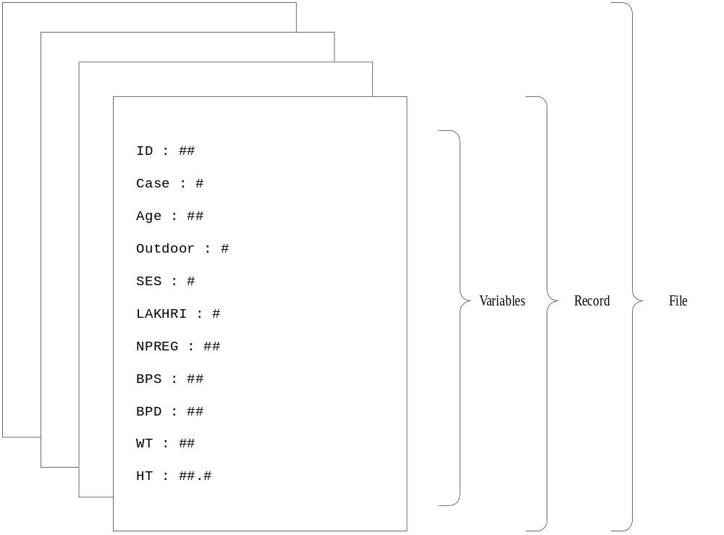

In our example, the records would be individuals interviewed / measured and the variables would be the answers to the questions asked or the results of measurements taken.

Data is usually represented in a table in which each row represents an individual case or record and each column represents a variable or field. Here are the first three records in the CATDAT.REC dataset:

ID | CASE | AGE | OUTDOOR | SES | LAKHRI | NPREG | BPS | BPD | WT | HT
10 | 2 | 45 | 2 | 1 | 2 | 7 | 130 | 70 | 50 | 1.60
79 | 2 | 38 | 2 | 2 | 2 | 5 | 110 | 60 | 64 | 1.65
90 | 2 | 35 | 2 | 1 | 1 | 5 | 100 | 70 | 50 | 1.62

Be careful when you read the word case. In a statistical or data-management context, case means a collection of variables relating to an individual person, laboratory record, disease notification, &c. In the context of a case-control study, case means an individual with the outcome of interest (e.g. cataract). The meaning depends upon the context.

Retrieving a dataset in ANALYSIS

Retrieving a dataset

ANALYSIS is the data analysis module of EpiInfo. With ANALYSIS you can use simple commands to produce lists, frequencies, statistics and graphs. Start EpiInfo and then start ANALYSIS.

Once ANALYSIS starts the screen is divided into several distinct sections. The upper section is headed OUTPUT and the lower section is headed COMMANDS. At the top of the screen are two lines giving the status information:

Dataset: <None> Free memory: 250K
Use READ to choose a dataset

The status information shows the name of the current data file (dataset) and the amount of free memory in the system (this will depend on how your computer has been set up and is likely to differ from system to system). The bottom line of the screen shows the function keys available from within ANALYSIS:

Key | Function
l | Help
m | Menu of commands
n | Menu of variables in the current dataset
o | Browse the current dataset in ‘spreadsheet’ format
p | Printer on / Printer off
t | Temporary DOS session (type EXIT to get back to ANALYSIS)
u | Quit ANALYSIS

We need to tell ANALYSIS the name of the dataset we want to work with. The status information reminds you to do this:

Dataset: <None> Free memory: 250K
Use READ to choose a dataset

The data for this exercise is stored in an EpiInfo file called CATDAT.REC. Type:

read a:\catdat.rec

and press e. The name of the file and the number of records in the file will appear at the top of the screen, indicating that the file has been read:

Dataset: A:\CATDAT.REC (343 records) Free memory: 250K
Criteria: All records selected

Note that you need to press the e key to instruct ANALYSIS to act on any of the commands you type. You can edit the command line before you press e. The command is executed only after you press the e key. You can clear (i.e. delete) the command line by pressing |. ANALYSIS maintains a list of previously entered commands which you can scroll through using the w and y keys.

Examining a dataset

The BROWSE command

Look at the menu bar at the bottom of the screen showing the function keys available within ANALYSIS. Press the o key to browse through the data. The first twenty-one records appear on the screen, one record per line, with variables running across the line. Move around the file using the w, x, y, z, {, }, d and g keys. Their uses are:

Keys | Action
{, } | move up & down through the records (rows)
g, d | move to the top & bottom records (rows)
w, x, y, z | move between variables (columns) or records (rows)

Press o again to select full screen mode. You now have a single record displayed above the menu bar. Look at the menu bar and work out how to move to the next record and back to the previous one. Try this a few times. Press o again to return to ‘spreadsheet’ mode. When you have finished looking at the data press u to return to the main ANALYSIS screen. Note that the word BROWSE appeared in the COMMANDS window, as a result of pressing o. We could have typed the command BROWSE instead of pressing the o key.

The LIST command

If we want to see the variables in a dataset and examine them variable-by-variable and record-by-record we would use the BROWSE command. If we want to see data as a list we would use the LIST command. Type:

list id case age outdoor ses lakhri

The ID, CASE, AGE, OUTDOOR, SES, and LAKHRI variables (together with the internal record number) for all records in the dataset are listed on the output screen. Since it is impossible to view all 343 records on the screen at the same time, they are listed one page at a time (each page showing fourteen records). The word <more> at the bottom of the output screen means there are more pages of output to come. Press any key to see the next page of output. If you do not want to see any more output, press ^. When <more> no longer appears at the bottom of the output screen you are at the bottom of the listing. You can scroll back through the listing using the { and } keys. You can also use b with the { and } keys to scroll up and down the output screen one line at a time.

BROWSE and LIST commands

You can use the BROWSE and LIST commands on their own to view the entire dataset (i.e. all variables for all records) or you can specify a list of variables to view. The command:

list bps bpd wt ht

and the command:

browse bps bpd wt ht

both allow you to examine the contents of the BPS, BPD, WT, and HT variables. The BROWSE command is more flexible (‘spreadsheet’ and full-screen modes, easy scrolling between variables and cases, output not limited to the width of the screen) but sends output to the screen only. If you want to list variables and records to a printer or to a file then you should use the LIST command.
Subsets of data

The SELECT command

If we wanted to work with data for a subset of records we would use the SELECT command to select only those records we wanted to work with. Type:

select case = 1

Any subsequent commands we type will be performed only with the data for cases (CASE = 1). Note that the status information at the top of the screen changes to reflect the Selection criteria:

Dataset: A:\CATDAT.REC (343 records) Free memory: 250K
Criteria: case = 1

Type the command:

list id case age outdoor ses

If we page through the output screen, we can see that only cases (CASE = 1) are listed. Now suppose we want to work with the controls (CASE = 2). If we type:

select case = 2

No records will be selected (check this using the LIST or BROWSE commands). This is because there can be no records where CASE = 1 and CASE = 2 at the same time:

Dataset: A:\CATDAT.REC (343 records) Free memory: 250K
Criteria: (case = 1) AND (case = 2)

What we must do is cancel the previous SELECT statement, so that all records are selected again. Type:

select

The SELECT command on its own instructs ANALYSIS to work with all of the records in a dataset. Note that the selection criteria at the top of the screen now shows that all records are selected:

Dataset: A:\CATDAT.REC (343 records) Free memory: 250K
Criteria: All records selected

Issue another SELECT command to SELECT the controls:

select case = 2

Examine the selection criteria at the top of the screen. Use the BROWSE or LIST command and scroll through the listing to check that this new SELECT command has worked as expected.

Issue the SELECT command on its own:

select

to clear the current selection criteria and continue working with all records in the dataset.

Subsets of data

More complex selections

The expression (e.g. CASE = 1) used with the SELECT command can be a complex expression using a combination of inequality operators:

Operator | Meaning | Example
= | equal to | case = 1
<> | not equal to | case <> 1
< | less than | npreg < 5
> | greater than | npreg > 5
<= | less than or equal to | npreg <= 5
>= | greater than or equal to | npreg >= 5

and Boolean operators:

Operator | Meaning | Example
and | both expressions must be true | case = 1 and npreg < 5
or | either of the expressions may be true | case = 1 or npreg < 5
not | the expression must not be true | case = 1 and not npreg < 5

Boolean operators are symbols used to express logic and to test the validity (truth) of a logical expression in an algebraic way. Boolean operators always separate expressions that can only be true or false (e.g. ‘Is the number of pregnancies less than five?’) and always return true or false values. Here are the truth tables for the AND and OR Boolean operators:

AND |  |  |  | OR
First Expression | Second Expression | Resulting Expression |  | First Expression | Second Expression | Resulting Expression
false | false | false |  | false | false | false
true | false | false |  | true | false | true
false | true | false |  | false | true | true
true | true | true |  | true | true | true

The NOT operator reverses the resulting expression (i.e. true becomes false and false becomes true).

Parentheses can be used to create complex expressions or to group expressions. Examples are:

Example | Selected Records
case = 1 | Cases
case = 1 and ses = 1 | Poor cases
case = 1 and ses = 1 and lakhri = 1 | Poor, lakhri eating cases
case = 1 or ses = 1 | Cases and poorer women
case = 1 or (ses = 2 and lakhri = 1) | Cases and wealthy lakhri eaters
case = 2 | Controls
case = 2 and age <= 40 | Younger controls
case = 2 and age <= 40 and ses = 1 | Younger, poorer controls
case = 2 or ses = 1 | Controls and poorer women
case = 2 or (ses = 1 and age <= 40) | Controls and younger, poorer women

The Boolean operators may appear to work against common sense but it is not difficult to build expressions using them as long as you remember that AND excludes records (all expressions must be true) whereas OR includes them (only one expression need be true).
Subsets of data

Entering commands in ANALYSIS

There are two methods of issuing commands to the ANALYSIS program. You may either type the command directly at the keyboard or choose commands and variables from menus.

Pressing the m key brings up a menu of available commands. To select a command from the menu you must first move the highlighted bar using the arrow keys. When the highlighted bar is over the command you wish to use press e to select it. To execute the command press e again. With most commands you will need to specify at least one variable.

Pressing the n key brings up a menu of variables in the current dataset. Variables can be selected from the menu in the usual way. To select just one variable point to it using the arrow keys and press e. To select a group of variables point to each one in turn and press the + key. When you have selected all the variables you need press e. If you select a variable by mistake you can deselect it using the - key.

Getting help on commands

There are two ways of getting help on commands in ANALYSIS. If you press l before you have typed a command then ANALYSIS will present you with a menu with options for help on general topics and specific commands. Options are selected from the menu in the usual way. If you want help on a specific command then type the command (e.g. LIST) and press l. ANALYSIS will respond with help for the command you typed.

If there is more than one screen of help on a particular topic or command then PgDn will be displayed in the bottom right hand corner of the help window. Pressing }will display the next screen of information.

Press ^ to return to ANALYSIS.

Leaving ANALYSIS

To leave ANALYSIS press u or type the command:

quit

and press e. This will return you to the EpiInfo main menu.
Producing charts

The shape of data

Charts are an ideal way of looking at how data in a variable is distributed. The distribution of a variable can be thought of as the shape of the data in that variable. Using charts we can see the shape of the data and answer the following types of questions about a variable:

Are the data values similar to each other?

Are the data values different from each other?

How different are the data values from each other?

Is there a single group of data values?

Are there several groups or clusters of data values?

Are a few data values very different from the majority of data values?

Questions like these cannot easily be answered by looking at a list of the data values in a variable. Charts allow us to see important features in the data. A chart is a picture of the data that allows us to see the overall structure of data rather than the confusing detail of individual data values.

Producing charts

ANALYSIS chart types

You can produce five different types of chart with ANALYSIS:

ANALYSIS Command | Chart Type
pie variable | Pie chart of the specified variable
bar variable | Bar chart of the specified variable
histogram variable | Histogram of the specified variable
line variable-1 [variable-2] | Line plot of variable-1 [by levels of variable-2]
scatter x-variable y-variable [/r] | Scatter plot of two variables [with regression line]

Start ANALYSIS and retrieve the CATDAT.REC dataset by typing:

read a:\catdat.rec

Suppose we want to examine the distribution of the CASE (case or control) variable. We could produce a BAR chart by typing:

bar case

After examining the chart, we can remove it from the screen by pressing ^ (the graph does not appear in the output screen). You can produce a HISTOGRAM of the NPREG (number of pregnancies) variable using the HISTOGRAM command:

histogram npreg

You can produce a PIE chart of the OUTDOOR (outdoor occupation) variable using the PIE command:

pie outdoor

or a LINE plot (frequency polygon) of the WT (weight) variable using the LINE command:

line wt

You can also use the LINE command to examine the difference between groups. The command:

line wt case

shows separate lines for cases and controls. The labels for the lines (1 and 2) are taken from the values of the CASE variable (i.e. 1 = CASE, 2 = CONTROLS).

To produce a SCATTER plot of two variables, showing how one varies with the other, use the SCATTER command which takes the general form:

scatter x-variable y-variable

The first variable listed (x-variable) will be plotted along the horizontal (x) axis and the second variable listed (y-variable) will be plotted along the vertical (y) axis as in:

scatter wt ht

If you add /R to the end of a SCATTER command it will display a regression line showing the linear (straight line) relationship between the two variables:

scatter wt ht /r
Chart types and their uses

Analysis chart types and their uses

Each type of chart has a different use. The table below summarises their use:

Chart | Examples | Description
PIE | pie case  pie ses | Used to display the proportion (percentage) of records for each value of a categorical variable. Segments of the pie represent the proportion of records with different values of the variable. Pie charts should be used for non-ordered data (e.g. sex). They are not appropriate for ordered data (e.g. age groups) and can be difficult to read when used to chart variables with more than five or six values (categories). Bar charts are preferred to pie charts when used to chart ordered data or non-ordered data with more than five or six categories.
BAR | bar case  bar ses  bar outdoor | Used to display the count of records in each category of a categorical variable. Vertical bars represent counts of records with different values of the variable. Bar charts differ from histograms in having bars separated by spaces and in omitting counts for values (categories) with a count of zero.
HISTOGRAM | histogram npreg  histogram wt  histogram ht | Used to display the distribution of values in a continuous variable. Vertical bars represent counts of records with different values of the variable. Histograms differ from bar graphs in having the bars contiguous (not separated by spaces) and in displaying counts for values with a count of zero.
LINE | line wt  line wt case | Used to display the distribution of values in a continuous variable. Points on the line represent counts of records with different values of the variable. More than one line may be charted by giving the name of an additional (categorical) stratifying variable. Charts with multiple lines can be difficult to read when the stratifying variable has more than three or four categories (i.e. when the chart displays more than three or four lines). Line charts are often used to show trends or movement in the value of a variable over time (time-series).
SCATTER | scatter wt ht | Used to investigate and display the relationship between two continuous variables. Points on the scatter plot represent pairs of values (i.e. the values for each of the variables within the same case). The first value (x) defines the horizontal position of the point. The second value (y) defines the vertical position of the point. For example, the value pair (3,4) would be represented as:  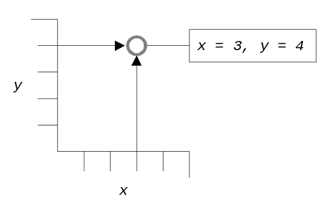  A non-random appearance to the plot indicates that there is an association between the two variables.
Practical exercises

Exercise 1 - Examining a dataset

How many records are there in the dataset stored in CATDAT.REC?

SELECT only those persons who have an outdoor occupation. Use BROWSE or LIST to see how many records are selected? How many records are selected in each of the categories of the CASE variables?

Clear the selection so that you can continue to work with all of the cases.

SELECT only those persons who are aged less than 40 years. Use BROWSE or LIST to see how many records are selected? How many records are selected in each category of the CASE variable?

Clear the selection so that you can continue to work with all of the records.

Exercise 2 - Producing charts

Produce a HISTOGRAM of NPREG. Which is the most common number of pregnancies? What is the smallest number of pregnancies? What is the largest number of pregnancies?

Produce a PIE chart of OUTDOOR. What proportion of the study population worked outdoors?

Produce a BAR chart of OUTDOOR. How many subjects worked outdoors?

Produce a HISTOGRAM, PIE chart, and LINE plot of the NPREG variable. Which chart do you think is the most appropriate and why?

Produce a HISTOGRAM of the AGE variable. Can you explain the shape of the graph? Check the distributions of the other continuous variables (NPREG, BPS, BPD, WT, HT) using the HISTOGRAM command.

Produce a SCATTER plot of the BPS variable and BPD variables. Produce the same chart again but with a regression line.

Summarising distributions

Frequency distributions

The frequency distribution, percentage frequency distribution and cumulative percentage frequency distribution of a variable can be produced using the FREQ command:

freq ses

This can be done for several variables in the same command:

freq ses lakhri npreg

The FREQ command produces a table listing counts, percentages, and cumulative percentages for each value of the specified variable. If the variable is numeric, the FREQ command will also display some summary statistics which may (or may not be) meaningful:

SES ¦ Freq Percent Cum.
------+-----------------------
1 ¦ 151 44.0% 44.0%
2 ¦ 192 56.0% 100.0%
------+-----------------------
Total ¦ 343 100.0%

Total Sum Mean Variance Std Dev Std Err
343 535 1.560 0.247 0.497 0.027

Minimum 25%ile Median 75%ile Maximum Mode
1.000 1.000 2.000 2.000 2.000 2.000

In this case the summary statistics (sum, mean, standard deviation, &c.) are meaningless because SES (socio-economic status) is a categorical variable (i.e. it contains codes that indicate membership of mutually exclusive categories). The quoted value for the mean (1.560) does not point somewhere between being rich and poor. The mean and standard deviation are not of use when dealing with categorical data. Many ANALYSIS commands will provide summary statistics and the results of statistical tests whether they are appropriate or not. It is up to you to decide if the output of any command is relevant. The summary statistics produced by the FREQ command are only useful when analysing continuous data:

NPREG ¦ Freq Percent Cum.
------+-----------------------
1 ¦ 13 3.8% 3.8%
2 ¦ 43 12.5% 16.3%
3 ¦ 58 16.9% 33.2%
4 ¦ 80 23.3% 56.6%
5 ¦ 53 15.5% 72.0%
6 ¦ 49 14.3% 86.3%
7 ¦ 18 5.2% 91.5%
8 ¦ 14 4.1% 95.6%
9 ¦ 7 2.0% 97.7%
10 ¦ 6 1.7% 99.4%
11 ¦ 2 0.6% 100.0%
------+-----------------------
Total ¦ 343 100.0%

Total Sum Mean Variance Std Dev Std Err
343 1535 4.475 4.075 2.019 0.109

Minimum 25%ile Median 75%ile Maximum Mode
1.000 3.000 4.000 6.000 11.000 4.000

Use the l help key to find out more about the FREQ command. Practice using the FREQ command with other variables.

Examine the output of the FREQ command carefully, making sure that you can interpret it.
Practical exercise

Exercise 3 - Summarising distributions

Use the FREQ command to examine the distribution of the HT variable. How many people were shorter than 1.50 metres? What was the most common height? How many people were taller than 1.65 metres?

Use the FREQ command to examine the distribution of the LAKHRI variable. What percentage of subjects regularly consumed LAKHRI dahl. Use the BAR and PIE commands to chart the distribution of the LAKHRI variable.

The table below was produced using the command FREQ NPREG. Examine the table carefully and mark on the table the positions of the values of the variable, the counts for each value of the variable, the percentage for each value of the variable, the cumulative percentages, and the total number of cases:

NPREG ¦ Freq Percent Cum.
------+-----------------------
1 ¦ 13 3.8% 3.8%
2 ¦ 43 12.5% 16.3%
3 ¦ 58 16.9% 33.2%
4 ¦ 80 23.3% 56.6%
5 ¦ 53 15.5% 72.0%
6 ¦ 49 14.3% 86.3%
7 ¦ 18 5.2% 91.5%
8 ¦ 14 4.1% 95.6%
9 ¦ 7 2.0% 97.7%
10 ¦ 6 1.7% 99.4%
11 ¦ 2 0.6% 100.0%
------+-----------------------
Total ¦ 343 100.0%

Total Sum Mean Variance Std Dev Std Err
343 1535 4.475 4.075 2.019 0.109

Minimum 25%ile Median 75%ile Maximum Mode
1.000 3.000 4.000 6.000 11.000 4.000

Are there any problems with using the sum, mean and standard deviation to summarise this distribution?

Summarising distributions

Categorical variables

Variables such as CASE, OUTDOOR, SES, and LAKHRI are stored as a set of mutually exclusive codes. Such variables are known as categorical variables. With categorical variables it makes sense to use the FREQ command to produce a frequency distribution as this allows us to investigate the count (i.e. number) and proportion of cases that belong to each group and to identify groups with many or few members:

CASE ¦ Freq Percent Cum.
------+-----------------------
1 ¦ 85 24.8% 24.8%
2 ¦ 258 75.2% 100.0%
------+-----------------------
Total ¦ 343 100.0%

Total Sum Mean Variance Std Dev Std Err
343 601 1.752 0.187 0.432 0.023

Minimum 25%ile Median 75%ile Maximum Mode
1.000 2.000 2.000 2.000 2.000 2.000

Beware of the summary statistics presented below frequency tables as they are meaningless for categorical variables.

Continuous variables

Some variables, such as AGE, NPREG, BPS, BPD, WT, HT, hold continuous data. A frequency distribution is of different use with such variables as each value will account for only a small proportion of cases and does little to help us understand how the variable is distributed. As an example, produce a frequency distribution of the NPREG variable by issuing the command:

freq npreg

If you study the resulting table closely enough you will be able to extract some useful information from it.
Frequency distributions of continuous data

Summarising continuous data with a frequency table

This is the frequency distribution of the NPREG variable. Important information has been highlighted:

NPREG ¦ Freq Percent Cum.
------+-----------------------
1 ¦ 13 3.8% 3.8% <- minimum value
2 ¦ 43 12.5% 16.3%
3 ¦ 58 16.9% 33.2%
4 ¦ 80 23.3% 56.6% <- most common (modal) & middle (median) values
5 ¦ 53 15.5% 72.0%
6 ¦ 49 14.3% 86.3%
7 ¦ 18 5.2% 91.5%
8 ¦ 14 4.1% 95.6%
9 ¦ 7 2.0% 97.7%
10 ¦ 6 1.7% 99.4%
11 ¦ 2 0.6% 100.0% <- maximum value
------+-----------------------
Total ¦ 343 100.0% <- number of observations (cases)

Total Sum Mean Variance Std Dev Std Err
343 1535 4.475 4.075 2.019 0.109

Minimum 25%ile Median 75%ile Maximum Mode
1.000 3.000 4.000 6.000 11.000 4.000

The highlighted information is known as the seven figure summary and can be used to summarise the distribution of continuous data. The seven summary measures are:

summary measure | formula | description
minimum | NONE | lowest value in the dataset
median | NONE | middle item in the dataset
mode | NONE | most common value in the dataset
maximum | NONE | highest value in the dataset
number of observations (n) | NONE | number of observations
mean () | 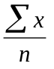 | sum of the observations divided by the number of observations
standard deviation | 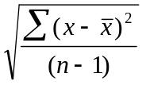 | a measure of how much the distribution varies around the mean

Some texts refer to this as the six figure summary. This is because they replace the minimum and maximum with the range which is the difference between the maximum value and the minimum value.

Note that in this example the modal (most frequent) and median (middle) values are the same. This will not always be the case.
Summarising distributions of continuous data

The seven figure summary

With continuous data we are not interested in the counts of cases for each particular height, weight, or score. We are more interested in the complete distribution. This can be summarised with two separate measures: A measure of the central tendency and a measure of the variability of the data. The seven figure summary yields both measures:

Measuring | Measure
central tendency | mode  median  mean
variability | range (maximum - minimum)  standard deviation

To understand why you need to examine both central tendency and variability consider the following two distributions:

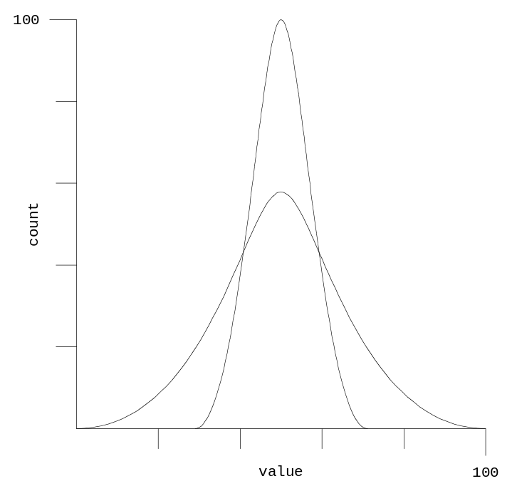

The two distributions shown on the graph have similar mean, median, and modal values. If we just used these measures of central tendency to describe the distributions we would not be describing them properly. We would conclude that they were the same as each other. As well as reporting the central tendency we also need to report the variability of the two distributions using the range and the standard deviation:

measure | wide | narrow
mean | 50 | 50
median | 50 | 50
mode | 50 | 50
range | 100 | 50
standard deviation | 15 | 8

This allows us to see that one distribution has a wider range of values (i.e. it is more variable) than the other.
Summarising distributions of continuous data

How the standard deviation measures variability

The formula for the standard deviation appears complicated:

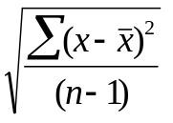

but it can be easily understood once broken down into its component steps. The formula relies on subtracting the mean from each data value:

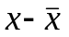

and summing (adding up) the deviations (differences):

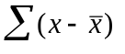

The positive and negative deviations will cancel each other out (giving zero) so each of the deviations is squared (multiplied by itself) to give positive values before summation:

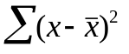

The sum of the squared deviations is divided by the number of cases contributing to the mean minus one:

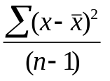

This gives a measure of average deviation from the mean which is known as the variance. The variance is expressed in squared units which are difficult to interpret. To get over this problem, the square root of the variance is used:

This measure is known as the standard deviation and is a measure of average deviation from the mean expressed in the original unit of measure. The more variable the data, the larger the standard deviation will be.

The Greek letter sigma (Σ) is used in statistical formulae to denote the sum of a series of numbers. Squaring a number (multiplying a number by itself) is a convenient way of turning negative numbers into positive numbers and is used in many statistical formulae for this purpose.

Standard deviation - worked example

Calculating the standard deviation

The table below shows four data points, their sum, and their mean:

 | Data
 | 3
 | 7
 | 6
 | 4
Sum | 20
Mean | 5

The first step in calculating the standard deviation is to subtract the mean from each data point to give the deviation of each data point from the mean:

 | Data | point - mean
 | 3 | -2
 | 7 | +2
 | 6 | +1
 | 4 | -1
Sum | 20 | 0
Mean | 5

Because the deviations add-up to zero, they are squared to make them all positive numbers:

 | Data | point - mean | (point - mean)2
 | 3 | -2 | 4
 | 7 | +2 | 4
 | 6 | +1 | 1
 | 4 | -1 | 1
Sum | 20 | 0 | 10
Mean | 5

Dividing the sum of the squared deviations by the number of data points minus one gives us the variance:

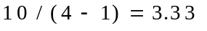

Taking the square root of the variance gives us the standard deviation:

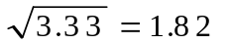

Standard deviation and degrees of freedom

Why use n - 1 instead of n to calculate the standard deviation?

The standard deviation is calculated by taking the square root of the sum of the squared deviations from the mean divided by the number of cases minus one:

Note that n - 1 is used to calculate the average squared deviation. This is because subtracting the mean from each value leads to the ‘loss’ of one item of data. The deviations may not be any group of n numbers. The sum of the deviations is always zero. When n - 1 deviations are specified, the last one is determined by the condition that they sum to zero:

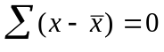

The final deviation is the sum of the other deviations with a change of sign (i.e. a positive number will become negative or a negative number will become positive). This is known as the loss of a degree of freedom. The deviations have n - 1 degrees of freedom because the final deviation has to have a particular value once n - 1 deviations are specified. You can see this ‘loss’ in this example with four data points:

 | Data | n deviations | n - 1 deviations
 | 3 | -2 | -2
 | 7 | +2 | +2
 | 6 | +1 | +1
 | 4 | -1 | ??
Sum | 20 | 0 | +1
Mean | 5

The sum of n - 1 deviations determines the value of the missing deviation which is marked ‘??’ in the table. The sum of n - 1 deviations is +1 so the missing deviation must be -1 because the sum of all deviations must be zero. As the missing deviation can be determined from n - 1 deviations and the constraint that the sum of deviations must be zero, there are really only n - 1 pieces of information (degrees of freedom) for the deviations.

The range and the standard deviation

Both the range and the standard deviation measure variability. The range is simple to calculate but has an undesirable property. It is calculated using the two extreme values only (the minimum value and the maximum value). Any outliers (extremely high or low values) will be included in these extremes making the range extremely sensitive to (potentially erroneous or unrepresentative) outliers in the data. The standard deviation is often preferred to the range because all data points (not just two) are used and it is less effected (but may still be distorted) by outliers in the data.

Problems with the mean and standard deviation

The normal distribution

The mean and standard deviations describe a particular type of distribution very well. This distribution is symmetrical and bell shaped with mean median and mode similar to each other:

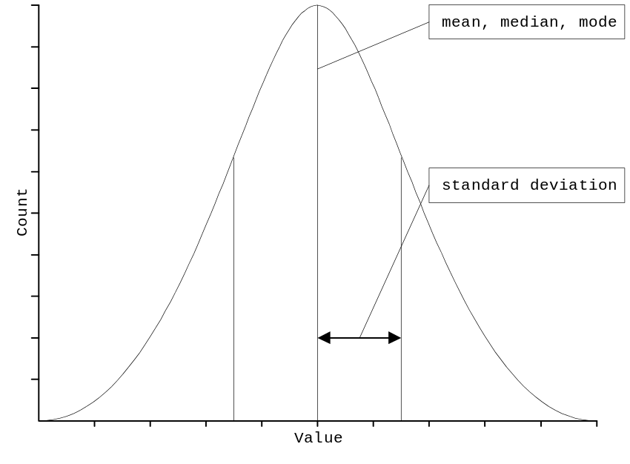

and is called the normal distribution. If your data has a very different type of distribution then the mean and standard deviation may not describe the distribution well. With non-normal distributions it may be best to use alternative measures of central tendency (e.g. the median) and variability (e.g. the range or inter-quartile distance) or apply a transformation to your data to bring it closer to the normal distribution.

Fortunately, the normal distribution is very common in nature. Many of the variables you collect will be normally distributed and you will be able to use the mean and standard deviation to describe them accurately.

It is very unlikely that you will see a perfectly normal distribution each time you chart your data. Random variation in the data will tend to make the distributions look ragged and may also make the distribution slightly non-symmetrical. There will usually be a few extreme or outlier values in the left and right tails of the distribution. If the data values tend to cluster in a symmetrical manner around a central value and there are progressively fewer and fewer data values as you move outward from the middle value and there are no data values that are very far way from the bulk of the other data values then you may safely assume that the data come from a variable that is normally distributed and that it is reasonable to use the mean and standard deviation to summarise the distribution.
Summarising distributions of continuous data

Calculating summary measures in analysis

ANALYSIS provides the MEANS command for dealing with continuous data. The MEANS command produces summary measures by different levels of a grouping variable (e.g. a mean NPREG for each category of CASE). If we want to look at the summary measures for a variable without displaying the tables of values and frequencies we must use the /N (for no table) command modifier. Issue the command:

means npreg /n

to instruct ANALYSIS to calculate and display summary measures for the NPREG variable. The command produces a frequency table and a table showing summary measures:

Total Sum Mean Variance Std Dev Std Err
343 1535 4.475 4.075 2.019 0.109

Minimum 25%ile Median 75%ile Maximum Mode
1.000 3.000 4.000 6.000 11.000 4.000

Examine the output carefully and make sure that you can identify all of the measures of the seven figure summary.

In addition to the seven figure summary, ANALYSIS also reports the cut-point values for the quartiles:

Total Sum Mean Variance Std Dev Std Err
343 1535 4.475 4.075 2.019 0.109

Minimum 25%ile Median 75%ile Maximum Mode
1.000 3.000 4.000 6.000 11.000 4.000

These values divide the distribution into four equal sized groups and can also be a useful way of summarising a distribution. The 25th percentile (lower quartile) and the 75th percentile (upper quartile) are the boundary values for the middle 50% of the data. The interquartile range or interquartile distance (i.e. 75th percentile - 25th percentile) is sometimes used as an alternative measure of variability. The advantage of using the interquartile range (instead of the range or the standard deviation) is that it is not effected by outliers.

Summarising distributions with charts

Categorical data

You can summarise categorical data using BAR and PIE charts. This is because these charts plot absolute counts (BAR charts) and counts as a proportion (percentage) of the sample population (PIE charts). Issue the following commands:

pie case
bar case

Both charts show the same thing. They are graphical equivalents of the FREQ command:

freq case

The BAR chart shows counts and the PIE chart shows proportions (percentages).

Continuous data

Continuous data can be summarised using either histograms or line charts. Issue the following commands:

histogram ht
line ht

This sort of line chart is sometimes called a frequency polygon. You can also use the LINE command to show the distribution of a continuous variable grouped by levels (values) of a categorical variable. Issue the command:

line ht case

The labels for the lines (1 and 2) are taken from the values of the CASE variable.

Practical exercise

Exercise 4 - Summarising distributions

Use the MEANS command to produce the seven figure summaries for the AGE, NPREG, BPS, BPD, WT, and HT variables and complete the following table:

 | AGE | NPREG | BPS | BPD | WT | HT
number of cases
mode
median
mean
minimum
maximum
standard deviation

Use the HISTOGRAM command to graph the distributions of the AGE, NPREG, BPS, BPD, WT, and HT variables.

The command:

histogram wt

produces the following graph:

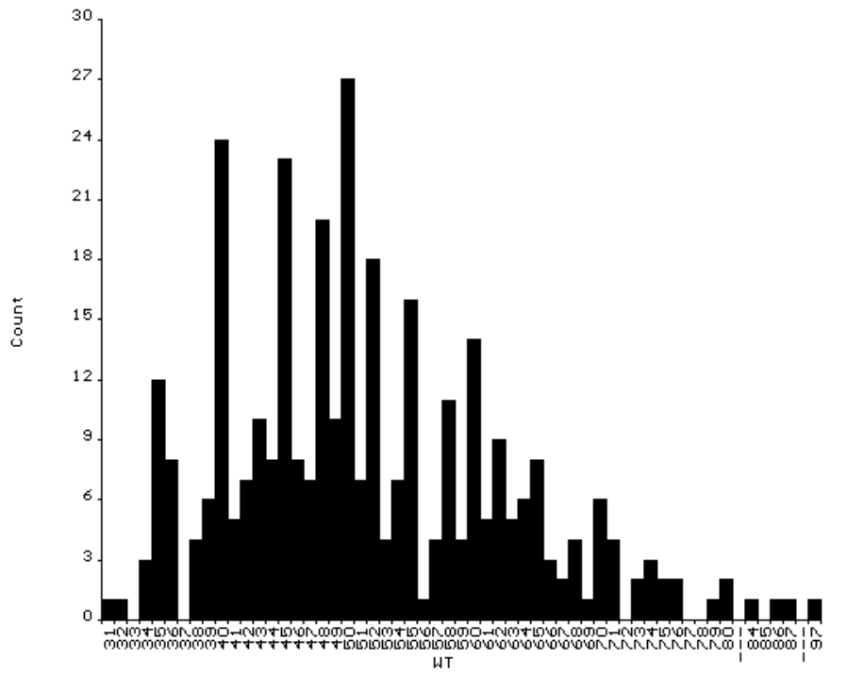

Mark the mode, median, and mean, minimum, and maximum (from the previous part of this exercise) on this graph.
Creating and recoding variables

The DEFINE command

To create a new variable (e.g. HYPER to indicate hypertension) you first need to tell ANALYSIS what kind of variable HYPER will be using the DEFINE command. Variable types that could be used for the new variable are:

Typical Values | Variable Type | DEFINE ‘Code’
1, 2 | Number | #
Y, N | Logical (Yes/No) | <Y>
+, - | Character | <A>
HIGHBP, NORMBP | Character | <AAAAAA>

Issue the command:

define hyper <AAAAAA>

to create a new character variable called HYPER. The number of characters between the angle brackets (‘<’ and ‘>’) defines the length of new variable. Use the ANALYSIS help system to discover how other codes can be used with the DEFINE command.

Press o BROWSE. You should see a blank column at the right hand side of the data file which has the heading HYPER. ANALYSIS has assigned a new character column for this variable. At present all the values are blank (or ‘missing’).

Recoding continuous variables into categorical variables

Issue the command:

recode bpd to hyper lo-90="NORMBP" 91-hi="HIGHBP"

to RECODE the number variable BPD into the character variable HYPER. The RECODE command must be issued after defining the new variable. Your data file now has the original variable BPD and a new variable HYPER. The choice of cut-points for group membership is often arbitrary and can make a difference to the results of analysis. With variables such as BPD it is valid to choose a cut-point of 90 because diastolic blood pressures values above this are generally considered to be abnormal. Sometimes an agreed definition of cut-points for (e.g.) high and low groups for a particular continuous measure will not be available. With these variables, you might choose cut-points such as the mean, median, mode, or quartiles.

The keywords LO and HI indicate the lowest and highest values of a particular variable.

After using RECODE you should always check to see if the command has had the expected result using the LIST or BROWSE commands.

An alternative way of recoding data is to use the IF ... THEN command. Try this by typing:

define hyper2 #
hyper2 = 2
if bpd > 90 or bps > 140 then hyper2 = 1

The advantage of using the IF ... THEN command is that it allows you to combine data from more than one variable. In this example we have used BPD > 90 or BPS > 140 to define hypertension.

Check the results of the IF ... THEN commands using the o BROWSE command. Examine the distribution of HYPER and HYPER2 using the FREQ command.
Creating and recoding variables

Recoding continuous variables into categorical variables

We will also use the RECODE command to create two age groups (1 = Older, 2 = Younger) based on the median (middle) value of the AGE variable. We can find the median of the AGE variable using the FREQ or MEANS command:

freq age /n
means age /n

These commands produce identical output:

Total Sum Mean Variance Std Dev Std Err
343 13939 40.638 12.202 3.493 0.189

Minimum 25%ile Median 75%ile Maximum Mode
35.000 38.000 40.000 45.000 45.000 40.000

Examine the output. Identify the median value of the AGE variable. Issue the following commands to create a variable (AGEGRP) split around the median value of AGE:

define agegrp #
recode age to agegrp lo-40=2 41-hi=1

Use the BROWSE or LIST command to check the results of the RECODE command.

We can do the same for the NPREG variable. First find the median using the MEANS command:

means npreg /n

Examine the output of this command:

Total Sum Mean Variance Std Dev Std Err
343 1535 4.475 4.075 2.019 0.109

Minimum 25%ile Median 75%ile Maximum Mode
1.000 3.000 4.000 6.000 11.000 4.000

and identify the median value of the NPREG variable. Issue the following commands to create a variable (NPREGGRP) split around the median value of NPREG:

define npreggrp #
recode npreg to npreggrp lo-4=2 5-hi=1

Use the BROWSE or LIST command to check the results of the RECODE command.

Creating and recoding variables

Creating variables based upon calculations

Not all recoding of variables will be based on groupings. You might, for example, want to define variables based upon calculations performed using the values of one or more variables. In the CATDAT.REC dataset we have variables holding weight (WT) for height (HT) but no index of weight for height (e.g. body mass index) that could be used to decide whether a subject was underweight, normal weight, or overweight.

In this example we will create a variable called BMI (body mass index) calculated from WT and HT and then use the DEFINE and RECODE commands to create a binary categorical variable (UW) to indicate underweight.

Issue the commands:

define bmi ##.#
bmi = wt / (ht * ht)

These two commands create a new variable called BMI which contains the result of dividing each subject’s weight (WT) by the square of their height (HT * HT).

Use the LIST or BROWSE command to check the results of the calculation.

Issue the commands:

define uw #
recode bmi to uw lo-18.50=1 18.51-hi=2

These two commands create a new variable called UW which indicates whether a subject’s body mass index (BMI) is less than or equal to 18.5 which is a generally agreed cut-point for undernutrition in adults.

Use the LIST or BROWSE command to check the results of the calculation.

You can find out what types of calculation are supported by ANALYSIS if you look up the item Operators in the ANALYSIS help system.

Saving recoded data

Saving changes to an EpiInfo dataset

Variables that you create during an ANALYSIS session using the DEFINE, RECODE, IF ... THEN, and assignment (i.e. commands with the form variable = expression) commands are temporary. The new variables will not be saved when you quit ANALYSIS. If you want to save the variables created during an ANALYSIS session you must use the ROUTE and WRITE RECFILE commands.

The ROUTE command is a general ANALYSIS command that specifies a file that is to be used for output. You could use the ROUTE command to save the output of any ANALYSIS command. In this case we will use ROUTE to specify a file to store the output of the WRITE RECFILE command. The route command requires you to specify a filename.

The WRITE RECFILE command displays the contents of the current dataset. When used with the ROUTE command this command will create a copy of the current dataset including created variables. The WRITE RECFILE command used alone will write all variables to a file. You may also specify a list of variables to write to a file or use the NOT keyword to exclude variables.

Issue the commands:

route catwork.rec
write recfile case outdoor ses lakhri hyper2 agegrp npreggrp uw

to create a file called CATWORK.REC containing only the variables of interest. Having thoroughly examined our data and performed some data-management we are now ready to start analysing the data.

Two-by-two tables

Two-by-two tables : Naming of parts

Measures of association between two variables are easily studied by means of two-by-two contingency tables. Such a table is presented below:

Outcome

Exposure | Cases | Non-Cases | Totals
------------+---------------+---------------+--------------
Present | a | b | a + b
------------+---------------+---------------+--------------
Absent | c | d | c + d
------------+-------------------------------+--------------
Totals | a + c | b + d | a + b + c + d

a = number exposed and case
b = number exposed and not case
c = number unexposed and case
d = number unexposed and not case
a + b = number exposed
c + d = number unexposed
a + c = number case
b + d = number not case
a + b + c + d = number in study

With the CATWORK.REC data, the command:

tables outdoor case

produces the following table:

CASE
OUTDOOR ¦ 1 2 ¦ Total
-----------+---------------+------
1 ¦ 30 32 ¦ 62
2 ¦ 55 226 ¦ 281
-----------+---------------+------
Total ¦ 85 258 ¦ 343

as well as some summary statistics which we will cover. In this table our exposure variable is OUTDOOR and our outcome variable is CASE. Using the terms introduced above we have:

a = 30 = number exposed and case
b = 32 = number exposed and not case
c = 55 = number unexposed and case
d = 226 = number unexposed and not case
a + b = 62 = number exposed
c + d = 281 = number unexposed
a + c = 85 = number case
b + d = 258 = number not case
a + b + c + d = 343 = number in study

In this example exposed means OUTDOOR work. Make sure that you can identify these figures in the table before proceeding.

Two-by-two tables

The absolute risk

The absolute risk is the risk of an outcome happening to an individual belonging to a given population. This can be calculated from a 2-by-2 table as:

(a + c) / (a + b + c + d)

This is number of people experiencing illness divided by the total population at risk. From the table:

CASE
OUTDOOR ¦ 1 2 ¦ Total
-----------+---------------+------
1 ¦ 30 32 ¦ 62
2 ¦ 55 226 ¦ 281
-----------+---------------+------
Total ¦ 85 258 ¦ 343

The absolute risk can be calculated as:

(a + c) / (a + b + c + d) = 85 / 343 = 0.248 = 24.8%

Each person in the study ran a risk of 24.8% of being a case. This is the same as saying that 24.8% of people in the study are cases.

The absolute risk measures the absolute magnitude (prevalence) of a health problem in a population but provides no information regarding the association between risk factors (exposure variables) and outcomes. It is simply the proportion of individuals with a particular outcome in the study population.

It is only valid to calculate an absolute risk with data from a cross-sectional or cohort study (i.e. where members of the study population are selected according to their exposure status). It is not valid to calculate an absolute risk in this way with data from a case-control study (i.e. where members of the study population are selected according to their outcome status). In a case-control study using 20 cases (a + c) and 20 controls (b + d) the absolute risk would appear to be:

(a + c) / (a + b + c + d) = 20 / 40 = 0.50

If 10 cases (a + c) and 20 controls (b + d) had been selected the absolute risk would appear to be:

(a + c) / (a + b + c + d) = 10 / 30 = 0.33

In a case-control study the absolute risk is the ratio of cases to controls and cannot be used to make inferences about the prevalence of disease in the study population. It is not valid to calculate an absolute risk with data from a case-control study. The data in CATWORK.REC were collected as part of a case-control study. The absolute risk is not a valid measure in this context.
Two-by-two tables

Exposure specific risks

A more useful approach is to calculate exposure specific risks or attack rates. This yields a measure that can be interpreted as the risk of an outcome given an exposure which can easily be calculated from a two-by-two table:

CASE
OUTDOOR ¦ 1 2 ¦ Total
-----------+---------------+------
1 ¦ 30 32 ¦ 62
2 ¦ 55 226 ¦ 281
-----------+---------------+------
Total ¦ 85 258 ¦ 343

In this table the exposure specific risk of being a case can be calculated as:

a / (a + b) = 30 / (30 + 32) = 30 / 62 = 0.484 = 48.4%

Each person in the study who worked outdoors ran a risk of 48.4% of being a case. This is the same as saying that 48.4% of people who work outdoors are cases. This method makes specific reference to risk factors and will vary with each tabulation of exposure by outcome.

The exposure specific risk will be different for each exposure whereas the absolute risk does not vary with exposure. The exposure specific risk estimates the risk of an outcome given an exposure but reveals little about the excess risk associated with exposure.

It is not valid to calculate an exposure specific risk with data from a case-control study. The data in CATWORK.REC were collected as part of a case-control study. The exposure specific risk is not a valid measure in this context.
Two-by-two tables

Relative risk

One way of estimating the excess risk due to exposure is to compare exposure specific risks between exposed and unexposed groups. Given the following table:

CASE
OUTDOOR ¦ 1 2 ¦ Total
-----------+---------------+------
1 ¦ 30 32 ¦ 62
2 ¦ 55 226 ¦ 281
-----------+---------------+------
Total ¦ 85 258 ¦ 343

It is possible to calculate the risk of being a case for those working outdoors as:

a / (a + b) = 30 / (30 + 32) = 30 / 62 = 0.484 = 48.4%

and the risk of being a case for those not working outdoors as:

c / (c + d) = 55 / (55 + 226) = 55 / 281 = 0.196 = 19.6%

The easiest way of comparing these two risks is as a ratio. This is the risk of being a case having been exposed divided by the risk of being a ‘case’ having not been exposed and is calculated as:

(a / (a + b)) / (c / (c + d)) = (30 / 62) / (55 / 281) = 0.484 / 0.196 = 2.47

A person working outdoors was 2.47 times as likely to be a case as a person not working outdoors.

This ratio of risks is described as the relative risk or risk ratio. This is always greater than zero. A relative risk of less than one implies a decrease in risk associated with a given exposure and that the exposure may protect against an outcome. A relative risk of greater than one implies an increase in risk associated with a given exposure. A relative risk of one implies no increase or decrease in risk associated with exposure. In summary:

Relative Risk | Interpretation
< 1 | exposure may protect against outcome
= 1 | exposure not associated with outcome
> 1 | exposure may increase risk of outcome

It is not valid to calculate a relative risk with data from a case-control study. The data in CATWORK.REC were collected as part of a case-control study. The relative risk is not a valid measure in this context.

Two-by-two tables

Odds ratio

The examples given above assume that it is valid to calculate a relative risk or risk ratio. It is only valid to calculate the relative risk or risk ratio in a study which has not selected subjects according to their outcome status (i.e. a study which has not selected cases and controls). The risk ratio is a valid measure of excess risk in a cohort study, where subjects have been selected according to their exposure status, or in a cross-sectional study.

In a case-control study an arbitrary number of cases and controls are selected for entry into the study. In this situation it is no longer reasonable to use the total numbers of ‘ill’ and ‘not-ill’ persons (cases and controls) to calculate exposure-specific risks and relative risks. Another measure of association must be used which uses only the internal (rather than total) values in the table. This measure is the odds ratio. Consider the following table:

CASE
OUTDOOR ¦ 1 2 ¦ Total
-----------+---------------+------
1 ¦ 30 32 ¦ 62
2 ¦ 55 226 ¦ 281
-----------+---------------+------
Total ¦ 85 258 ¦ 343

In this example the odds of being a case for outdoor workers can be calculated as:

a / b = 30 / 32 = 0.938

The odds of being a case for non-outdoor workers can be calculated as:

c / d = 55 / 226 = 0.243

The odds ratio can be calculated as:

(a / b) / (c / d) = (30 / 32) / (55 / 226) = 0.938 / 0.243 = 3.85

Working outdoors was associated with a 3.85 fold increase in the odds of being a case. The odds ratio is interpreted a similar way to the relative risk:

Odds Ratio | Interpretation
< 1 | exposure may protect against outcome
= 1 | exposure not associated with outcome
> 1 | exposure may increase risk of outcome

Odds ratios and relative risks

The odds ratio and relative risk measure excess risk in an exposed group compared to an unexposed group. In cohort and cross-sectional studies the odds ratio will overestimate the effect of exposure and the relative risk is preferred. In case-control studies the relative risk cannot be estimated and the odds ratio must be used. In case-control studies of rare outcomes the odds ratio provides a valid estimate of the relative risk.

The relative risk is not a valid measure of excess risk to use with the CATWORK.REC data because subjects were selected by their outcome status (case or control) rather than their exposure status (e.g. working outdoors).

The odds ratio is a valid measure of excess risk to use with the CATWORK.REC dataset because subjects were selected by their outcome status (case or control) rather than their exposure status (e.g. working outdoors).
Two-by-two tables

Measures of risk

If we examine the two-by-two table:

CASE
OUTDOOR ¦ 1 2 ¦ Total
-----------+---------------+------
1 ¦ 30 32 ¦ 62
2 ¦ 55 226 ¦ 281
-----------+---------------+------
Total ¦ 85 258 ¦ 343

of OUTDOOR by CASE closely we can extract the following information:

exposed and case | outdoor = 1 and case = 1 | a | 30
exposed and not case | outdoor = 1 and case = 2 | b | 32
unexposed and case | outdoor = 2 and case = 1 | c | 55
unexposed and not case | outdoor = 2 and case = 2 | d | 226
exposed | outdoor = 1 | a + b | 62
unexposed | outdoor = 2 | c + d | 281
case | case = 1 | a + c | 85
not case | case = 2 | b + d | 258
total records | sum of all the cells in the table | a + b + c + d | 343

Identify these figures in the displayed table.

We can use this information to calculate various risk measures:

absolute risk | (a + c) / (a + b + c + d) | 85 / 343 | 0.25
exposure specific risk | a / (a + b) | 30 / 62 | 0.48
relative risk | (a / a + b) / (c / c + d) | (30 / 62) / (55 / 281) | 2.47
odds ratio | (a / b) / (c / d) | (30 / 32) / (55 / 226) | 3.86

Check that you understand how to obtain these risk measures presented in this table before proceeding.

In this context (i.e. a case-control study) the odds-ratio is the only valid measure of excess risk that can be calculated from a two-by-two table.
Two-by-two tables

Measures of risk

ANALYSIS calculates relative risks and odds ratios for two-by-two tables together with confidence limits:

Odds ratio 3.85
Cornfield 95% confidence limits for OR 2.06 < OR < 7.20
Maximum likelihood estimate of OR (MLE) 3.83
Exact 95% confidence limits for MLE 2.06 < OR < 7.14
Exact 95% Mid-P limits for MLE 2.14 < OR < 6.87
Probability of MLE >= 3.83 if population OR = 1.0 0.00000611

RISK RATIO(RR)(Outcome:CASE=1; Exposure:OUTDOOR=1) 2.47
95% confidence limits for RR 1.74 < RR < 3.51

and reminds you to:

Ignore risk ratio if case control study

ANALYSIS will calculate the absolute risk and exposure specific risk if you issue the command:

set percents = on

before the TABLES command. This command instructs ANALYSIS to display row and column percentages in tables. To see the effect of this issue the command:

tables outdoor case

This command now produces the following output:

CASE
OUTDOOR ¦ 1 2 ¦ Total
-----------+-------------+------
1 ¦ 30 32 ¦ 62 <- Counts
> 48.4% 51.6% > 18.1% <- Row percentages
¦ 35.3% 12.4% ¦ <- Column percentages
2 ¦ 55 226 ¦ 281
> 19.6% 80.4% > 81.9%
¦ 64.7% 87.6% ¦
-----------+-------------+------
Total ¦ 85 258 ¦ 343
¦ 24.8% 75.2% ¦

The values in each cell of the table are presented as count, row percentage, column percentage. Examine the table. The row percentage of the cell OUTDOOR = 1 and CASE = 1 is equivalent to the exposure specific risk or attack rate (48.4%) and the row percentage of the column total for CASE = 1 is the absolute risk (24.8%). Note that neither of these measures are valid for a case-control study.

To instruct ANALYSIS to stop displaying cell percentages issue the command:

set percents = off

The interpretation of the relative risk produced by the TABLES command depends on the orientation of the table. The correct format for the TABLES command is:

tables risk-variable outcome-variable

The risk or exposure variable (e.g. OUTDOOR) should always be the first variable you specify with the TABLES command. The outcome variable (e.g. CASE) should always be the second variable you specify with the TABLES command.
Two-by-two tables

Confidence intervals

Measures of exposure effect are subject to random variation. The calculated odds ratio will differ from the true or population odds ratio because of random variation. If the study were to be repeated using different samples from the same population the calculated odds ratio would be slightly different for each sample. The sample odds ratio is considered to be the best estimate of the true odds ratio. It is called the point estimate of the odds ratio. The effect of random variation can be accounted for statistically by calculating a range of values around the point estimate of the odds ratio that has a specified probability of including the true value of the odds ratio. The specified probability is called the confidence level and is usually 95% or, sometimes, 99%. The range of values that the true odds ratio could take is called the confidence interval. The endpoints (maximum and minimum) of the confidence interval are called the confidence limits.

With a 95% confidence interval we are 95% sure that the true odds ratio falls within the computed confidence interval. We do not know for certain that the true odds ratio lies within the confidence interval. The chances are 95% that the true odds ratio lies within the confidence interval. The chances are 5% that the true odd ratio lies outside of the confidence interval. There is a 2½% chance of the true odds ratio being below the lower confidence limit and a 2½% chance of the true odds ratio being above the upper confidence limit.

Confidence intervals can be calculated for relative risks, odds ratios, absolute risks and exposure-specific risks. The calculation of the confidence interval is complicated and is best left to purpose-designed computer programs such as ANALYSIS.

Interpretation of the confidence interval

The following odds ratio and 95% confidence limits have been calculated from the CATWORK.REC data (using the command TABLES OUTDOOR CASE) for the association between working outdoors and being a case:

Odds ratio 3.85
Cornfield 95% confidence limits for OR 2.06 < OR < 7.20

The observed odds ratio is 3.85. The true odds ratio is likely to lie somewhere between 2.06 and 7.20. The true odds ratio is unlikely to be equal to one. It is reasonable to state that working outdoors is associated with being a case.

The following odds ratio and 95% confidence limits have been calculated from the CATWORK.REC data for the association between hypertension (HYPER2) and being a case:

Odds ratio 1.69
Cornfield 95% confidence limits for OR 0.93 < OR < 3.08

The observed odds ratio is 1.69. The true odds ratio is likely to lie somewhere between 0.93 and 3.08. It is not unlikely that the true odds ratio is equal to one. It is not reasonable to state that hypertension was associated with being a case.

Two-by-two tables

Testing a hypothesis about association

Measures of exposure effect are subject to random variation. We can allow for this random variation by calculating a confidence interval that is likely to include the true measure of exposure effect. The confidence interval can also be used to test whether this association is likely to be real or whether it is likely to have arisen by chance. If the confidence interval for the odds ratio does not include one then the association is likely to be real. If the confidence interval includes one then the association is unlikely to be real.

Another way of assessing the association between exposure and outcome variables is to use hypothesis testing or significance testing. Statistical hypothesis testing relies on an assumption called the null hypothesis. This hypothesis states that nothing interesting is happening in the data other than random variation (i.e. that there is no association between an exposure and an outcome). The null hypothesis is used to test an alternative hypothesis that states that something interesting or systematic is happening in the data. Statistical hypothesis testing involves comparing the observed data with what we would expect the data to look like if the null hypothesis were true. Consider the following table:

CASE
OUTDOOR ¦ 1 2 ¦ Total
-----------+---------------+------
1 ¦ 30 32 ¦ 62
2 ¦ 55 226 ¦ 281
-----------+---------------+------
Total ¦ 85 258 ¦ 343

The null hypothesis is that outdoor work is not associated with being a case. The alternative hypothesis is that outdoor work is associated with being a case. The null hypothesis can be tested by comparing the numbers in each cell of the table with the numbers that we would expect to see if the null hypothesis were true.

From the table the proportion of people defined as cases is:

(a + c) / (a + b + c + d) = 85 / 343 = 0.248 = 24.8%

If the null hypothesis were true, the expected number of people being defined as cases working outdoors would be 24.8% of 62 (i.e. the probability of being a case would not vary with exposure if the null hypothesis were true), or:

Expected[a] = 62 * (85 / 343) = 15.36

Expected numbers for each of the cells in the table can be calculated in a similar way:

Expected[a] = 62 * (85 / 343) = 15.36

Expected[b] = 62 * (258 / 343) = 46.64

Expected[c] = 281 * (85 / 343) = 69.64

Expected[d] = 281 * (285 / 343) = 211.36

These expected values can then be compared with the actual or observed values from the data.
Two-by-two tables

Testing a hypothesis about association

Once the expected values have been calculated we can compare the table we observe from the data with the table we would expect to see if the null hypothesis were true:

OBSERVED EXPECTED
CASE CASE
OUTDOOR ¦ 1 2 ¦ Total OUTDOOR ¦ 1 2 ¦ Total
-----------+---------------+------ -----------+---------------+-------
1 ¦ 30 32 ¦ 62 1 ¦ 15.36 46.64 ¦ 62.00
2 ¦ 55 226 ¦ 281 2 ¦ 69.64 211.36 ¦ 281.00
-----------+---------------+------ -----------+---------------+-------
Total ¦ 85 258 ¦ 343 Total ¦ 85.00 258.00 ¦ 343.00

by subtracting the expected values from the values observed in the data:

CASE
OUTDOOR ¦ 1 2 ¦ Total
-----------+---------------+------
1 ¦ 14.64 -14.64 ¦ 0.00
2 ¦ -14.64 14.64 ¦ 0.00
-----------+---------------+------
Total ¦ 0.00 0.00 ¦ 0.00

Positive and negative differences cancel each other out so we square the number in each cell to make them all positive numbers:

CASE
OUTDOOR ¦ 1 2 ¦ Total
-----------+---------------+-------
1 ¦ 214.33 214.33 ¦ 428.66
2 ¦ 214.33 214.33 ¦ 428.66
-----------+---------------+-------
Total ¦ 428.66 428.66 ¦ 857.32

before dividing them by the expected values:

CASE
OUTDOOR ¦ 1 2 ¦ Total
-----------+---------------+-------
1 ¦ 13.95 4.59 ¦ 18.54
2 ¦ 3.07 1.01 ¦ 4.08
-----------+---------------+-------
Total ¦ 17.02 5.60 ¦ 22.62

The overall total of this table (22.62) is a measure of how much the observed data differs from the data expected under the null hypothesis. It is called the chi-square statistic:

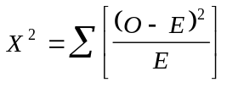

The Greek letter sigma (Σ) is used in statistical formulae to denote the sum of a series of numbers. Squaring a number (multiplying a number by itself) is a convenient way of turning negative numbers into positive numbers and is used in many statistical formulae for this purpose.

Under the null hypothesis there is a fixed probability of obtaining this particular chi-square value. If the probability of obtaining 22.62 under the null hypothesis is small then the null hypothesis is unlikely to be true and we would assume that there is an association working outdoors and being a case. If the probability of obtaining 22.62 under the null hypothesis is large then the null hypothesis might be true and we would not assume that there is an association between outdoor work and being a case.

Chi-square, degrees of freedom, and p-values

Chi-squares, degrees of freedom, and p-values

The probability of observing a particular chi-square value is determined by the chi-square distribution. There is a different chi-square distribution for each size of table. A large chi-square is more likely to arise from a large table (i.e. a table with many cells) than from a small table (i.e. a table with few cells such as a 2-by-2 table). The more rows and columns in a table the larger the chi-square value is likely to be. This is because there are more cells in which the observed values are free to vary from the expected values. The number of cells in which the observed values are free to vary from the expected values is called the degrees of freedom. In this table:

CASE
OUTDOOR ¦ 1 2 ¦ Total
-----------+---------------+------
1 ¦ 30 ?? ¦ 62
2 ¦ ?? ?? ¦ 281
-----------+---------------+------
Total ¦ 85 258 ¦ 343

knowing the value of one internal cell allows us to determine the values of the other three internal cells. This table has one degree of freedom. The degrees of freedom in a table is calculated using the formula:

df = (number of rows - 1) * (number of columns - 1)

The degrees of freedom in a 2-by-2 table are:

df = (number of rows - 1) * (number of columns - 1) = (2 - 1) * (2 - 1) = 1

The chart on the next page shows the probability of observing chi-square values at different degrees of freedom. Look at the chi-square distribution for one degree of freedom. The probability of getting a chi-square value of 22.62 from a 2-by-2 table is very small. This probability is referred to as the p-value and is the probability that the observed association arose by chance. If we refer to the chi-square distribution with one degree of freedom in a set of statistical tables we obtain a p-value of less than 0.0001. The probability that the observed association arose by chance is less than 0.0001 (i.e. less than one in ten thousand). It is unlikely that the observed association arose by chance. It is reasonable to reject the null hypothesis of no association. It is generally considered safe to reject the null hypothesis with a p-value less than 0.05 (i.e. less than one in twenty). When the p-value is less than 0.05, the association between the row and column variables is said to be statistically significant.

There are several chi-square tests. The one described here is called Pearson's chi-square. Another test of association is Yates' corrected chi-square which uses the same formula but includes a correction factor and is used for two-by two tables. Yates' corrected chi-square is always slightly smaller than Pearson's chi-square and will always yields a slightly larger p-value. Most statisticians prefer Yates’ corrected chi-square because it is more conservative and less likely to yield a significant p-value when the null hypothesis is true. Another test of association is Fisher’s exact test. This is based on a distribution called the hypergeometric distribution and is not a chi-square test. Chi-square tests can yield misleading results when expected numbers are small. Fisher's exact test is more robust and can yield reliable results with small expected numbers. Fisher’s exact test should be used instead of a chi-square test when any of the cells in the 2-by-2 table has an expected value of less than five. ANALYSIS will report Pearson's chi-square for all tables and Yate's corrected chi-square for two-by-two tables. If an expected value in a two-by-two table is less than five then ANALYSIS will also report Fisher's exact test. There are two p-values associated with Fisher’s exact test: the one-tailed p-value and the two-tailed p-value. The one-tailed p-value is appropriate when we are interested in examining the effects of exposure variables in one direction only (e.g. do they increase the risk or odds of illness?). In other types of study we are usually testing for any association and would use a two-tailed p-value. If in doubt you should use the two-tailed p-value. The one-tailed p-value might be appropriate here because we are interested in examining the effects of an exposure variables in one direction only.
Chi-squares, degrees of freedom, and p-values

The chi-square distribution

The chart below shows the probability of observing chi-square values at three different degrees of freedom:

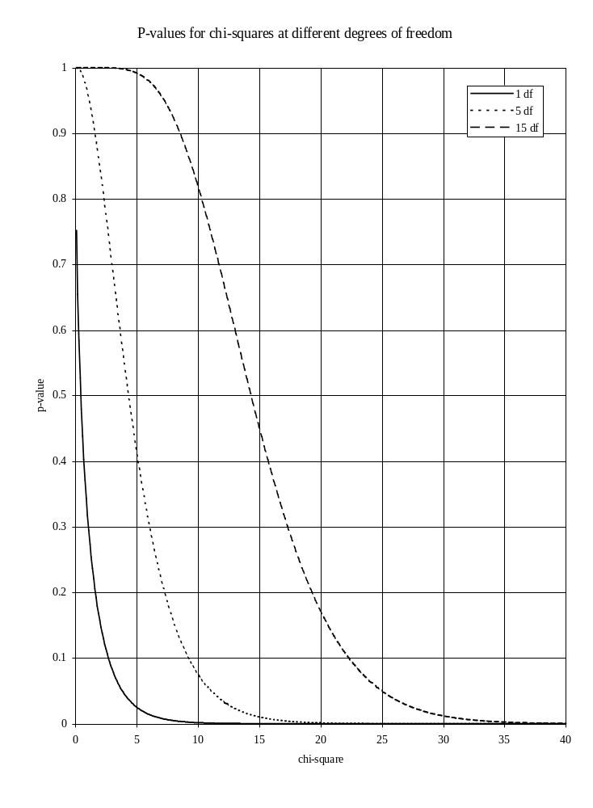
Mark a chi-square value of 22.62 on the x-axis (chi-square on x-axis) and estimate the probability of calculating this value from data in a 2-by-2 table (p-value on y-axis) if the null hypothesis were true. Remember that a 2-by-2 table has one degree of freedom.

Two-by-two tables

Confidence intervals and significance tests

Both confidence intervals and significance tests can be used to test for an association between exposure and outcome variables. They are related approaches to the same problem. If the 95% confidence interval for an odds ratio does not include one then the chi-square will have a p-value of less than 0.05 (5%). The confidence interval (or estimation) approach is preferred as it provides an estimate of the magnitude and direction of the effect and the variability of the estimate. The statistical significance testing approach only indicates the consistency of the data with the null hypothesis and provides no estimate of the magnitude or direction of the effect. Both approaches are influenced by sample size. Large numbers in cells will yield large chi-square values. Consider using a chi-square test to establish whether an association exists between hypertension and being a ‘case’:

CASE
HYPER2 ¦ 1 2 ¦ Total
-----------+-------------+------
1 ¦ 25 51 ¦ 76
2 ¦ 60 207 ¦ 267
-----------+-------------+------
Total ¦ 85 258 ¦ 343

This table yields a chi-square statistic of 3.45 with a p-value of 0.0633. If we assume that the sample size of the study had been three times larger (by multiplying all cells in the table by three) the following table would result:

CASE
HYPER2 ¦ 1 2 ¦ Total
-----------+-------------+------
1 ¦ 75 153 ¦ 228
2 ¦ 180 621 ¦ 801
-----------+-------------+------
Total ¦ 255 774 ¦ 1029

which yields a chi-square statistic of 10.35 (3 * 3.45) with a P-value of 0.0013. The chi-square value has been influenced by the sample size. We might (wrongly) assume that the effect of hypertension was larger in the second table. If we perform the same experiment but calculate the relative risk and confidence interval we get the following results:

Odds ratio 1.69
Cornfield 95% confidence limits for OR 0.93 < OR < 3.08

for the original table and:

Odds ratio 1.69
Cornfield 95% confidence limits for OR 1.21 < OR < 2.37

for the table with increased sample size. The point estimate is the same but the confidence interval is narrower. Increasing the sample size will give a smaller p-value and a narrower confidence interval.

You should never multiply the numbers in a 2-by-2 table to get a significant p-value or a narrower confidence interval. The only valid method of increasing the sample size is to collect more data!

Two-by-two tables

An example of ANALYSIS output

The following table was produced using the command TABLES OUTDOOR CASE. Important information has been highlighted:

CASE
OUTDOOR ¦ 1 2 ¦ Total
-----------+-------------+------
1 ¦ 30 32 ¦ 62
2 ¦ 55 226 ¦ 281
-----------+-------------+------
Total ¦ 85 258 ¦ 343

Single Table Analysis

Odds ratio 3.85 <- Odds Ratio
Cornfield 95% confidence limits for OR 2.06 < OR < 7.20 <- Confidence Limits
Maximum likelihood estimate of OR (MLE) 3.83
Exact 95% confidence limits for MLE 2.06 < OR < 7.14
Exact 95% Mid-P limits for MLE 2.14 < OR < 6.87
Probability of MLE >= 3.83 if population OR = 1.0 0.00000611

RISK RATIO(RR)(Outcome:CASE=1; Exposure:OUTDOOR=1) 2.47 <- Relative Risk
95% confidence limits for RR 1.74 < RR < 3.51 <- Confidence Limits

Ignore risk ratio if case control study

Chi-Squares P-values
----------- --------

Uncorrected: 22.62 0.00000197 <--- <- Chi-square/p-value
Mantel-Haenszel: 22.56 0.00000204 <---
Yates corrected: 21.10 0.00000435 <--- <- Corrected values

Notice that ANALYSIS produces three chi-square measures and p-values. With two-by-two tables you may quote either the uncorrected or corrected values. The corrected value is preferred as it is more conservative and less prone to error.

Two-by-two tables

Summary of measures introduced

The table below summarises the measures of effect and association introduced so far:

Measure | Value | Interpretation | Notes
Relative risk | < 1 | decrease in risk | not valid for case-control studies
 | = 1 | no effect
 | > 1 | increase in risk
Odds ratio | < 1 | decrease in risk | valid for case-control studies
 | = 1 | no effect
 | > 1 | increase in risk
Confidence interval | includes 1 | observed association could be due to random variation | applies to relative risk / odds ratio
 | excludes 1 | observed association unlikely to be due to random variation
P-value | > 0.050 | observed association could be due to random variation | applies to test statistic
 | < 0.050 | observed association unlikely to be due to random variation
 | < 0.010 | observed association very unlikely to be due to random variation
 | < 0.001 | observed association extremely unlikely to be due to random variation

Statistical models

An important idea in statistics and data analysis

The concept of a model is important in statistics and data analysis.

A model is a statement that we make about our data that can be tested against the data.

The chi-square test is an example of a model. With the chi-square test, the null hypothesis is the model. The null hypothesis model states that only random variation is present in the data. We then use this model to predict what our data would look like if the model accurately described the data (i.e. we calculate the values we expect to be in each cell of a table if the null hypothesis is true). We can then test the model against the data. If the values predicted by the model and the values found in the data match each other (i.e. the observed and expected values agree with each other) then the model is said to fit the data. If the values predicted by the model and the values found in the data match each other we accept the model as a good description of the data. Such a model is said to have a good fit. If the values predicted by the model and the values found in the data do not match each other then the model is rejected because it is not a good description of the data.

In using the chi-square test we have already used a statistical model. Later in this course we will use more complex models to describe and analyse our data.

Practical exercise

Exercise 5 - Two-by-two tables

Use the TABLES command to investigate the association between the exposure variables and case in the CATWORK.REC dataset and complete the table below:

 | Lower 95% CL | Odds ratio | Upper 95% CL | Yates' X2 | p-value
OUTDOOR | 2.06 | 3.85 | 7.20 | 21.10 | < 0.0001
SES
LAKHRI
HYPER2
AGEGRP
NPREGGRP
UW

Real and spurious associations

Analysing more than one exposure variables at the same time

Using the methods covered so far, you can find the effect of an exposure on the disease (using the odds ratio or relative risk) and test the statistical significance of this effect (using confidence intervals or statistical hypothesis testing). With the data in CATWORK.REC we find the following significant associations:

 | Lower 95% CL | Odds ratio | Upper 95% CL | Yates' X2 | p-value
OUTDOOR | 2.06 | 3.85 | 7.20 | 21.10 | < 0.0001
SES | 3.83 | 7.07 | 13.15 | 50.05 | < 0.0001
LAKHRI | 2.15 | 3.79 | 6.69 | 24.77 | < 0.0001
AGEGRP | 2.11 | 3.67 | 6.42 | 24.39 | < 0.0001
NPREGGRP | 1.05 | 1.77 | 3.01 | 4.68 | 0.0305
UW | 1.38 | 2.50 | 4.53 | 9.90 | 0.0017

These methods are appropriate for analysing the effect of exposure variables independently of one another. All of these associations may be real and independent of each other. It is likely, however, that some of these associations are due to associations between the exposure variables rather than independent associations between each exposure variable and the outcome variable.

It is easier to understand what might be happening in the data if we examine the associations between just two exposure variables and the outcome variable. Let us examine the associations between the SES, UW and CASE variables. SES is associated with being a case (OR = 7.07, 95% CI = 3.83 - 13.15) and UW is also associated with being a case (OR = 2.50, 95% CI = 1.38 - 4.53). There are three possible explanations for these results:
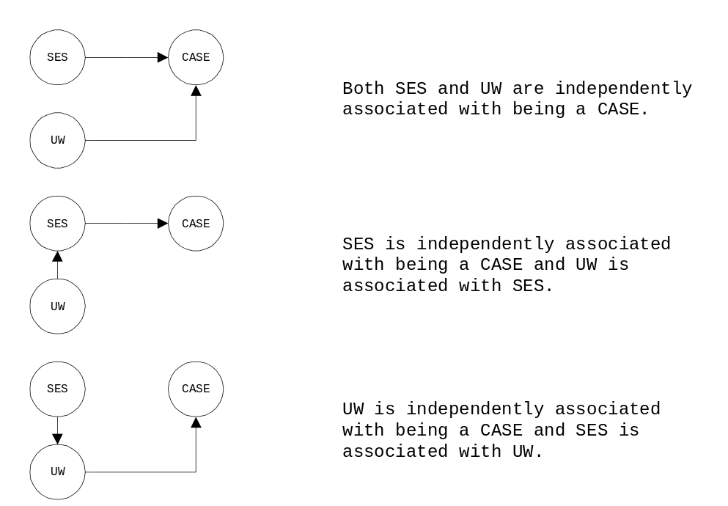

Another explanation is that neither SES nor UW alone were sufficient to cause the outcome and that both factors (low socio-economic status and undernourishment) were necessary to cause the outcome. This situation is relatively uncommon with communicable diseases but can occur with cases of chemical or environmental poisoning or with multifactorial diseases. The independent operation of two or more factors to produce, prevent, enhance, or limit an effect is known as interaction or effect-modification.
In statistical terms, each of these scenarios is known as a model. Each of these models can be tested against the data.

Real and spurious associations

Confounded associations

The two situations:
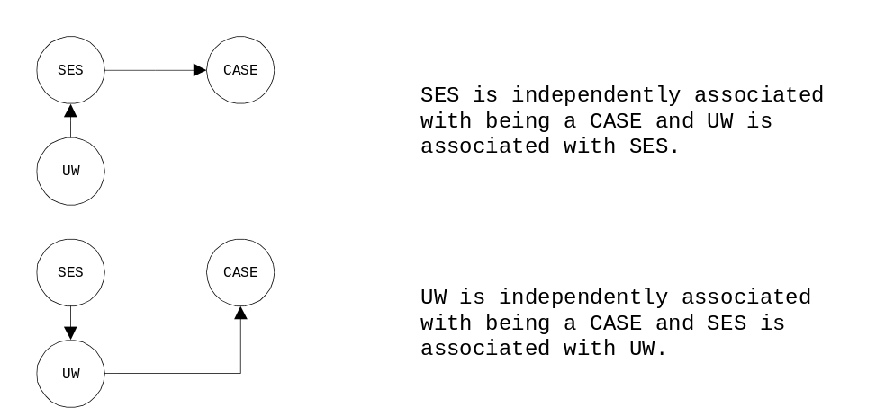

could arise if eating SES is associated with UW (and vice versa). This would cause SES to confound the relationship between UW and CASE. It would also cause UW to confound the relationship between SES and CASE. Confounding between variables may cause spurious associations to arise between exposure and the outcome variables. It may be that SES is associated with CASE and, because many of the people with low socio-economic status were also undernourished, it appeared that UW was also associated with CASE. A confounding variable is associated with both the outcome variable and the exposure variables. UW is a potential confounder if it is associated with CASE and SES. SES is a potential confounder if it is associated with CASE and UW.

You can use the Epi-Info ANALYSIS module to investigate whether an association exists between two exposure variables using the TABLES command. The command TABLES SES UW produces the following output:

UW
SES ¦ 1 2 ¦ Total
-----------+-------------+------
1 ¦ 53 92 ¦ 145
2 ¦ 22 168 ¦ 190
-----------+-------------+------
Total ¦ 75 260 ¦ 335

Single Table Analysis

Odds ratio 4.40
Cornfield 95% confidence limits for OR 2.42 < OR < 8.04
Maximum likelihood estimate of OR (MLE) 4.38
Exact 95% confidence limits for MLE 2.44 < OR < 8.07
Exact 95% Mid-P limits for MLE 2.52 < OR < 7.77
Probability of MLE >= 4.38 if population OR = 1.0 0.00000005

RISK RATIO(RR)(Outcome:UW=1; Exposure:SES=1) 3.16
95% confidence limits for RR 2.02 < RR < 4.94

Ignore risk ratio if case control study

Chi-Squares P-values
----------- --------

Uncorrected: 29.52 0.00000006 <---
Mantel-Haenszel: 29.43 0.00000006 <---
Yates corrected: 28.10 0.00000012 <---

SES and UW are strongly associated with each other. The odds ratio is not used in this context as neither variable can be properly classified as the exposure or outcome variable.
Real and spurious associations

Confounded associations

The significant association between SES and UW means that the models:

cannot be rejected. If we had found that there was no association between SES and UW then the only model that matched the data would be:

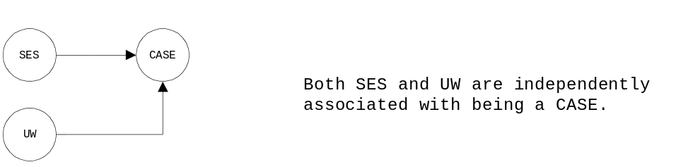

as this is the only model that does not require the existence of an association between UW and SES. Note that this model may still be a good description of the data as it does not require that no association between SES and UW exist.
Real and spurious associations

The Mantel-Haenszel relative risk and significance test

SES and UW are both associated with CASE. The odds ratio of being a case for SES is 3.83. To determine whether UW is a confounder of this relationship, you should look at the relationship between SES and CASE according to whether individuals were undernourished or not. This is called a stratified analysis because it is an analysis of one risk factor by outcome done separately for the different strata (i.e. different values) of another risk factor.

The 2-by-2 table below shows the association between SES and CASE for those who were undernourished:

UW = 1 ALL individuals are undernourished

CASE
SES ¦ 1 2 ¦ Total
-----------+-------------+------
1 ¦ 26 27 ¦ 53 Odds ratio = 6.10
2 ¦ 3 19 ¦ 22 Lower 95% confidence limit = 1.43
-----------+-------------+------ Upper 95% confidence limit = 29.92
Total ¦ 29 46 ¦ 75

There were 75 subjects who were underweight of whom 29 were cases. The odds ratio for SES in this group is 6.10 (95% CI: 1.43 - 29.92).

The following 2-by-2 table shows the association between SES and CASE for those who were not undernourished:

UW = 2 NO individuals are undernourished

CASE
SES ¦ 1 2 ¦ Total
-----------+-------------+------
1 ¦ 37 57 ¦ 94 Odds ratio = 6.21
2 ¦ 16 153 ¦ 169 Lower 95% confidence limit = 3.04
-----------+-------------+------ Upper 95% confidence limit = 12.79
Total ¦ 53 210 ¦ 263

There were 263 subjects who were not undernourished of whom 53 were cases. The odds ratio for SES in this group is 6.21 (95% CI: 3.04 - 12.79)

In this example, the odds ratios in each stratum are significant (i.e. the 95% confidence interval does not include one). This will not always be the case as each stratum is based on a reduced sample size. The significance of the odds ratios in each stratum is not important in stratified analysis. We only examine the stratum-specific odds ratios in order to ascertain whether it is appropriate to combine them into a single pooled odds ratio. It is not appropriate to combine these two odds ratios if the odds ratios for those who were undernourished and those who were not are very different. It is only valid to combine these two odds ratios to get a pooled odds ratio if the odds ratios for those who were undernourished and those who were not are similar (i.e. if the stratum-specific odds ratios can be considered as estimates of a common odds ratio).

In this case the odd ratio for those who were undernourished and for those who were not are sufficiently similar (both odds ratios are substantially greater than one, similar to each other in magnitude, and their confidence intervals overlap substantially). The pooled odds ratio is an average of the two odds ratios. In preference to a simple average, we calculate a weighted average that gives more weight to the strata with more data.
Real and spurious associations

The Mantel-Haenszel odds ratio and significance test

The simple weighted average approach runs into problems when strata contain few subjects and reliable estimates of stratum-specific odds ratios cannot be calculated. A better weighting scheme is proposed by Mantel and Haenszel.

The Mantel-Haenszel odds ratio is also called the weighted odds ratio or summary odds ratio. It provides a means of summarising odds ratios from different strata of a factor and in so doing, it adjusts for the confounding effect of this factor. An equivalent technique can be used to calculate a summary risk ratio. The crude (i.e. the odd ratio found in an unstratified analysis) and adjusted odds ratios should be compared to determine whether a variable is a confounder. If the adjusted odds ratio is much smaller than the crude odds ratio (at least 15-20% smaller) then there is evidence of confounding. If the adjusted odds ratio is a little smaller than the crude odds ratio (less than 15% smaller) then there is little or no evidence of confounding. If the adjusted odds ratio is much larger (at least 15-20% larger) than the crude odds ratio then there is evidence of negative confounding.

A significance test (the Mantel-Haenszel summary chi-square) can be used to test whether the Mantel-Haenszel odds ratio is significantly different from one (i.e. no association between exposure and outcome). The Mantel-Haenszel summary chi-square test is not a significance test for confounding. A large difference between the crude and adjusted relative risk is evidence of confounding. A significant Mantel-Haenszel summary chi-square suggests that the adjusted odds ratio is significantly different from one. This usually happens when there is little confounding but it is possible for the Mantel-Haenszel chi-square to be significant when there is substantial confounding.

When the Mantel-Haenszel odds ratio was calculated for the above example with Epi-Info ANALYSIS, the following results were obtained:

Mantel-Haenszel Summary Chi Square 39.42
P value 0.00000000
Mantel-Haenszel Summary Chi Square (uncorrected) 41.15
P value 0.00000000

SUMMARY ODDS RATIO
Crude OR 6.79
Mantel-Haenszel weighted Odds ratio 6.18
95% conf limits for M-H OR (Robins, Greenland, Breslow) 3.41 < OR < 11.20

The odds ratio calculated from the table for SES by CASE (without adjusting for the effect of UW) is called the crude or unadjusted odds ratio. The crude odds ratio is 6.79 which suggests that subjects with a lower socio-economic status were more likely to be cases than those who were not. The Mantel-Haenszel weighted odds ratio is 6.18 which suggests that after adjusting for the effect of UW, lower socio-economic status still increased the odds of being a case.

The fact that the odds ratio decreased by about 10% from 6.79 to 6.18 suggests that there was little confounding. What appeared to be the effect of undernourishment may have actually been due to other factors associated with lower socio-economic status. The adjusted odd ratio is still much larger than one and still statistically significant. After adjusting for UW, those persons of lower socio-economic status still had six times the odds of being a case than persons of higher socio-economic status.
Real and spurious associations

Testing for an interaction: Woolf's test

The Mantel-Haenszel odds ratio provides a means of summarising the odds ratio from different strata of a factor and in so doing, it adjusts for the effect of this factor. It is only appropriate to summarise the odds ratio from different strata if they are not very different from one another.

If the effect of factor A on the disease is different for the different strata of factor B (i.e. the odds ratio in the strata of factor B are very different), then there may be an interaction between factor A and factor B. If the effect of low socio-economic status on being a case is different for those who are underweight and those who are not underweight, then there may be an interaction between socio-economic status and nutritional status.

To test for an interaction between SES and UW, you must compare the odds ratio for SES for those who were undernourished with the odds ratio for SES for those who were not undernourished. Even if the true odds ratios for those who were undernourished and those who were not are equal they will differ due to random variation.

In this example there is only a small difference between the SES odds ratio among those who were undernourished (odds ratio = 6.10, 95% CI: 1.43 - 29.92) and among those who were not undernourished (odds ratio = 6.11, 95% CI: 2.98 - 12.63). These odds ratios have wide and overlapping confidence intervals. This suggests that the difference in odds ratios is probably due to random variation rather than an interaction

There is a way of testing more formally whether these two relative risks are equal. This is Woolf's test for heterogeneity of odds ratios. Woolf's test is another chi-square test. A Woolf's chi-square value with a p-value of less than 0.05 suggests that there is a significant difference between the two odds ratios (i.e. there is an interaction). Some statisticians regard a p-value of less than 0.10 (rather than 0.05) as evidence of an interaction. This is because the test is based on stratum-specific odds ratios. These are based on small numbers and are therefore less likely to yield small p-values.

EpiInfo ANALYSIS refers to Woolf’s test as ‘Chi-square for evaluation of interaction’. When Woolf's test was carried out on the odds ratios for SES for those who were undernourished and those who were not undernourished, the following results were obtained:

Chi Square for evaluation of interaction 0.00
P value 0.98145273
Test does not suggest that ORs differ by stratum (interaction)

Woolf's chi-square was equal to 0.00 which gave a p-value of 0.9815 suggesting that the observed difference between the two odds ratios probably arose by chance and that there is unlikely to be an interaction between SES and UW.

If Woolf's chi-square had yielded a significant p-value, then an interaction between SES and UW could not be ruled out. If an interaction does exist or is suspected, then it is not appropriate to combine the two odd ratio. If the effect of SES is different depending on whether subjects were undernourished or not, then this should be shown in the results section of your report by presenting the odd ratios separately. If Woolf's test yields a significant p-value, then the odds ratios should be presented separately and the Mantel-Haenszel summary measures should not be quoted.
Real and spurious associations

Stratified analysis with EpiInfo ANALYSIS

Start ANALYSIS. Once ANALYSIS has started issue the command:

read catwork.rec

to retrieve the data for the CATWORK.REC dataset. Use the TABLES command to investigate the association between SES and CASE controlling for UW by issuing the command:

tables ses case uw

which, along with tables of SES by CASE for each level of UW, produces the following output:

** Summary of 2 Tables With Non-Zero margins **
N = 338

Mantel-Haenszel Summary Chi Square 39.42
P value 0.00000000
Mantel-Haenszel Summary Chi Square (uncorrected) 41.15
P value 0.00000000

SUMMARY ODDS RATIO
Crude OR 6.79
Mantel-Haenszel weighted Odds ratio 6.18
95% conf limits for M-H OR (Robins, Greenland, Breslow) 3.41 < OR < 11.20
Maximum likelihood estimate of OR (MLE) 6.12
Exact 95% confidence limits for MLE 3.30 < OR < 11.76
Exact 95% Mid-P limits for MLE 3.42 < OR < 11.27
Probability of MLE >= 6.12 if population OR = 1.0 0.00000000

Chi Square for evaluation of interaction 0.00
P value 0.98145273
Test does not suggest that ORs differ by stratum (interaction)

Examine the output of this command carefully and identify the crude odds ratio, the Mantel-Haenszel summary odds ratio and its confidence limits, the Mantel-Haenszel summary chi-square and its associated p-value, and Woolf's test and its associated p-value.

Note that the number of records used in this analysis is 338 and not 345. This is because there are five missing values in the UW variable due to missing weights (WT) and heights (HT) in the original CATDAT.REC dataset. Missing values in any variable in a record will lead to that record being excluded from the analysis if that variable is being used in an analysis. The analysis may then be based on a small set of records and produce unreliable results. These five missing values also account for the slight difference in the crude odds ratio reported by the stratified analysis (OR = 6.79) and the unstratified analysis (OR = 7.07).

The format for the tables command is:

tables <exposure> <outcome> <confounder1> <confounder2> <confounder3>

The exposure variable should always be the first variable. The outcome variable must always be the second variable. The stratifying or confounding variables may follow. You may specify up to three stratifying or confounding variables with the TABLES command in ANALYSIS.

Real and spurious associations

Stratified analysis with EpiInfo ANALYSIS

Investigate the association between UW and CASE controlling for SES by issuing the command:

tables uw case ses

Examine the output of this command carefully and identify the crude odds ratio, the Mantel-Haenszel summary odds ratio and its confidence limits, the Mantel-Haenszel summary chi-square and its associated p-value, Woolf's chi-square and its associated p-value. Complete the table below:

Exposure: | SES
Outcome: | CASE
Controlling for : | UW
Crude OR: | 6.79
M-H summary OR: | 6.18
95% CI: | 3.41 - 11.20
M-H chi-square: | 39.42
p-value: | < 0.0001
Woolf's chi-square: | 0.00
p-value: | 0.9815

Exposure:
Outcome:
Controlling for :
Crude OR:
M-H summary OR:
95% CI:
M-H chi-square:
p-value:
Woolf's chi-square:
p-value:

After adjusting for UW, SES was still significantly associated with being a case. After adjusting for SES, UW was not significantly associated with being a case.

Many subjects with a low socio-economic status were undernourished. Low socio-economic status confounded the association between UW and CASE. This resulted in a spurious association between UW and CASE. It is likely that some factor (or factors) associated with low socio-economic status is a contributes towards the development of cataract in women but that it is unlikely to be undernourishment.
Real and spurious associations

Analysing several exposure variables at the same time

Using the methods covered so far, you can analyse the effect of an exposure on the disease (using the odds ratio), examine its effect having adjusted for other exposures (using the Mantel-Haenszel summary odds ratio) and test whether there is an interaction between these exposures (using Woolf's test).

These stratified analysis techniques can be extended to study the effect of several exposures simultaneously. For example, it would be possible to calculate the odds ratio for SES after adjusting for the effect of UW, LAKHRI, AGEGRP, NPREGGRP, and OUTDOOR. Several tables would be produced, one for every combination of the variables of interest.

With several potential confounders stratified analysis methods result in the analysis of many tables which are difficult to interpret and can yield unreliable results. Five potential confounders each with two levels would produce thirty-two tables for each exposure analysed. Some of these tables are likely to contain small numbers which may produce unstable or unreliable results. A better approach would be to use logistic regression.

EpiInfo ANALYSIS does not provide the facility to perform logistic regression analysis but an add-on program LOGISTIC.EXE can be used to perform logistic regression on EpiInfo datasets. This program can be found on the survey module course disk.

Before using LOGISTIC.EXE we must first recode the data into a format suitable for logistic regression analysis. Specifically, LOGISTIC.EXE requires that variables are codes 1 = YES and 0 = NO. It is relatively simple to do this recoding. Start ANALYSIS and issue the following commands:

read catwork.rec
recode case 1=1 2=0
recode outdoor 1=1 2=0
recode ses 1=1 2=0
recode lakhri 1=1 2=0
recode agegrp 1=1 2=0
recode npreggrp 1=1 2=0
recode uw 1=1 2=0
route catlog.rec
write recfile case outdoor ses lakhri agegrp npreggrp uw

These commands recode the variables of interest into the format required by LOGISTIC.EXE and create a new file called CATLOG.REC.

Quit ANALYSIS.
Logistic regression

The logistic model for a single exposure variable

Logistic regression is a statistical technique used for simultaneously estimating the effects of several exposure variables on an outcome variable. We will first use this technique to estimate the effect of a single exposure (SES) on the outcome variable (CASE). This is the 2-by-2 table for SES by CASE:

CASE
SES ¦ + - ¦ Total
-----------+-------------+------
+ ¦ 66 85 ¦ 151
- ¦ 19 173 ¦ 192
-----------+-------------+------
Total ¦ 85 258 ¦ 343

Various measures of disease (exposure-specific risk and absolute risk) and measures of effect (relative risk and odds ratio) can be calculated from this table. We want to relate a measure of disease or effect to the exposure of SES. Does low socio-economic status increase the risk of being a case? The relationship between the risk of being a case and socio-economic status can be represented by a model.

As an example of a model, consider the relationship between body mass index (BMI) and weight and height. BMI can be expressed in terms of weight and height using the following relationship or model:

BMI = weight / height2

It is possible to work out the BMI for every possible pair of values of weight and height. The model provides a useful way of summarising all possible combinations of BMI, weight, and height in one simple relationship.

We might represent the relationship between the risk of being a case (y) and low socio-economic status (x = 1 for low socio-economic status, x = 0 for higher socio-economic status) using the following model:

y = α + βx

An important difference between these two models is that the former is deterministic. For any given combination of weight and height, the model will determine a single value of BMI. The latter model is probabilistic. For a given value of SES the model can only give a probability of being a case. The relationships between exposures and diseases are usually represented by probabilistic models. The models covered in this course are all probabilistic models.

Consider the model:

y = α + βx

for the relationship between the risk of being a case and SES. There are techniques available for estimating suitable values of α and β. If we plotted this model for particular values of x and y, the graph would be linear. Such a linear model runs into problems when values of y (in this case, the probability of disease) have to lie within a certain range (such as between 0 and 1). The linear model assumes that y can take any value. There are no measures of disease or effect which meet this absence of constraint. There are, however, functions of these measures which do meet this constraint. One such function is the natural logarithm of the odds of disease.
Logistic regression

The logistic model for a single exposure variable

Using the standard notation for a 2-by-2 table:

Outcome

Exposure | Cases | Non-Cases | Totals
------------+---------------+---------------+--------------
Present | a | b | a + b
------------+---------------+---------------+--------------
Absent | c | d | c + d
------------+-------------------------------+--------------
Totals | a + c | b + d | a + b + c + d

a = number exposed and case
b = number exposed and not case
c = number unexposed and case
d = number unexposed and not case
a + b = number exposed
c + d = number unexposed
a + c = number case
b + d = number not case
a + b + c + d = number in study

the odds of disease (or the odds of being a case) for those exposed is a / b. The odds of disease for those not exposed is c / d. The overall odds of disease is the odds of disease irrespective of exposure. The overall odds of disease is estimated as:

(a + c) / (b + d)

The log odds of disease is estimated as:

log((a + c)/(b + d))

In the example table:

CASE
SES ¦ + - ¦ Total
-----------+-------------+------
+ ¦ 66 85 ¦ 151
- ¦ 19 173 ¦ 192
-----------+-------------+------
Total ¦ 85 258 ¦ 343

the odds of disease is equal to:

85 / 258 = 0.33

So the log odds of disease is equal to:

log(0.33) = -1.11

Logistic regression is a technique which allows us to relate the log odds of disease to an explanatory variable, x, using the linear model:

log odds of disease = α + βx

where α and β are coefficients to be determined.
Logistic regression

Estimating the coefficients in the model

Consider the situation with one explanatory variable (SES):

CASE
SES ¦ + - ¦ Total
-----------+-------------+------
+ ¦ 66 85 ¦ 151
- ¦ 19 173 ¦ 192
-----------+-------------+------
Total ¦ 85 258 ¦ 343

We will use the data shown in this table to estimate suitable values for the coefficients α and β in the model:

log odds of disease = α + βx

There are only two possible values of x for this model: these are x = 0 for a subject with a high socio-economic status and x = 1 for a subject with a low socio-economic status. We can calculate suitable values of α and β by calculating the log odds of disease at x = 0 and x = 1 for our data. The estimated value of the log odds of disease at x = 0 is used to find a suitable value of α. The log odds of disease for a subject with high socio-economic status (x = 0) is:

log odds of disease = α + βx
= α + β*0
= α

log odds of disease = log(c / d) = log(19 / 173) = -2.21
α = -2.21

A suitable value for α is -2.21. We can find a suitable value for β by calculating the log odds of disease at x = 1 and using α = -2.21. The log odds of disease a subject with a low socio-economic status (for x = 1) is:

log odds of disease = α + βx
= α + β*1
= α + β

log odds of disease = log(a / b) = log(66 / 85) = -0.25
α + β = -0.25
β = -0.25 - α
β = -0.25 - (-2.21)
β = 1.96

A suitable value for β, which is a measure of the excess risk associated with low socio-economic status, is 1.96. The logistic model for this table can be written as:

log odds of disease = -2.21 + 1.96x

This means that for a subject with low socio-economic status (x = 1), the log odds of disease is equal to -2.21 + 1.96 = -0.25 and for subject with high socio-economic status, the log odds of disease is equal to -2.21. We have used the log odds of disease to estimate suitable values for α and β. Conversely, given values for α and β we can estimate the log odds of disease and the odds ratio:

α = the log odds of disease in the unexposed group
β = the log odds ratio associated with being exposed

The calculation of the coefficients of the model (α and β) is complicated when there is more than one exposure variable and is best left to purpose-designed computer programs such as LOGISTIC.EXE.
Logistic regression

Fitting the model using LOGISTIC.EXE

Here are the results from the logistic regression of SES carried out using LOGISTIC.EXE:

Standard
Coefficient Error Coef/SE "P value"

CONSTANT -2.2089 .2417 -9.1394 .0000
SES 1.9559 .2921 6.6956 .0000

95.0-% confidence limits
Coefficient Odds ratio
lower upper lower upper
limit limit limit limit

SES 1.3833 1.9559 2.5284 3.9882 7.0700 12.5332

The column labelled coefficients in the above output lists the estimates of α and β: α is equal to the coefficient for the CONSTANT (-2.21) and β is equal to the coefficient for SES (1.96). The model which relates SES to the log odds of disease is therefore:

log odds of disease = -2.21 + 1.96x

This is the same as the logistic model for the 2-by-2 table shown previously. The coefficient for β is equal to the log(odds ratio) which means that the odds ratio for eating eggs is:

exp(1.96) = e1.9559 = 7.07

where exp denotes the exponential function (or anti-logarithm). We can check this figure against the one calculated directly from the 2-by-2 table:

CASE
SES ¦ + - ¦ Total
-----------+-------------+------
+ ¦ 66 85 ¦ 151
- ¦ 19 173 ¦ 192
-----------+-------------+------
Total ¦ 85 258 ¦ 343

Odds ratio = (66 / 85) / (19 / 173) = 7.07

The logistic regression module of the course software also calculates a 95% confidence interval for the odds ratio:

Odds ratio
lower upper
limit limit

3.9882 7.0700 12.5332

Logistic regression

Significance tests

Once the model which best describes the data has been found, it is important to test the significance of those variables included in the model. The logistic regression module gives the results of two tests of significance of exposure variables.

The first test of significance is the likelihood ratio test. This measures the significance of a variable by comparing the model which includes this variable to the model which does not include this variable. For example, to assess the significance of SES in the model, you would compare the model with SES to the model without SES.

The model with SES is:

log odds of disease = -2.21 + 1.96 * SES

The model without SES is of the form:

log odds of disease = -2.21

which is the appropriate model when the probability (risk) of disease is constant and not dependent upon SES. If you fit this model to the data, you would get:

log odds of disease = log ((a + c) / (b + d)) = log (85 / 258) = -1.11

The significance of SES is assessed by comparing the probability that:

α = -2.21, β = 1.96

with the probability that:

α = -1.11, β = 0

These two probabilities are called likelihoods and a good measure of their difference is given by r, the ratio of one to the other. This is the likelihood of the model without SES divided by the likelihood of the model with SES. For example, if the likelihood of the model without SES was 0.1 and the likelihood of the model with SES was 0.5, the ratio of likelihoods would be 0.1 / 0.5 = 0.2 which indicates that the model without SES is only 20% as likely as the model with SES. A formal measure of the difference in likelihoods is given by the likelihood ratio statistic which is equal to:

-2 * log(r)

and has a chi-square distribution with one degree of freedom. Large values of the likelihood ratio statistic indicate that the model with SES is more probable than the model without SES for the given data (i.e. that SES is associated with being a case). The likelihood ratio test assesses the significance of SES by comparing the likelihood ratio statistic with a chi-square distribution with one degree of freedom. Here is the result of the likelihood ratio test for SES:

H0: coeff = 0 lr statistic (1 df) P-value
SES 53.2212 .0000

The likelihood ratio statistic for SES is 53.22. This indicates that there is a large difference between the likelihoods of the two models. A chi-square statistic of 53.22 with one degree of freedom is highly significant (p < 0.0001). This result suggests that SES is strongly associated with being a case.

Logistic regression

Significance tests

The second test of significance is Wald's test. This test measures the significance of a variable by testing whether its coefficient in the model is significantly different from zero. Since the coefficient is equal to the log of the odds ratio and log(1) = 0 this is equivalent to testing whether an odds ratio is significantly different from one.

To assess the significance of SES in the model, you would test whether the coefficient of SES (β = 1.96) is significantly different from zero. A good measure of the difference between a coefficient and zero is given by R, the ratio of the coefficient to its standard error (a measure of how precisely the coefficient can be estimated from the sample). Large values of R indicate that the coefficient is not equal to zero. Wald's test assesses the significance of SES by comparing the square of R to a chi-square distribution with one degree of freedom. Here is the result of Wald's test for SES:

Standard
Coefficient Error Coef/SE "P value"

CONSTANT -2.2089 .2417 -9.1394 .0000
SES 1.9559 .2921 6.6956 .0000

Wald's test (Coef/SE)2 for SES gives 6.69562 which equals 43.8311 which, when compared to a chi-square distribution with one degree of freedom, is also highly significant (p < 0.0001). It is unlikely that the observed association between SES and being a case arose by chance alone. Note that comparing (Coef/SE)2 to a chi-square distribution with one degree of freedom is equivalent to comparing (Coef/SE) to a Normal distribution. Some textbooks and computer programs describe the latter procedure but the p-values from the two are identical.

Most statisticians recommend the use of the likelihood ratio test rather than Wald's test. This is because Wald's test is based on an approximation and the results may not be as accurate as those from the likelihood ratio test. In some situations, the p-value from Wald's test is larger than it should be. This may cause a significant variable to appear to be non-significant. This can occur when the absolute value of the coefficient is very large. In most situations, the p-value from Wald's test is similar to that from the likelihood ratio test.

Logistic regression

Starting LOGISTIC

Start the LOGISTIC.EXE by selecting Run... from the Windows Start Menu and typing a:\logistic.exe in the Run... dialog box. Once LOGISTIC.EXE starts you will be presented with its start-up screen:

---------------------------------------------------------------
## #### #### #### ##### ######## #### ####
## ## ## ## ## ## ## ## ## ## ## ##
## ## ## ## ## #### ## ## ##
## ## ## ## #### ## #### ## ## ##
## ## ## ## ## ## ## ## ## ## ## ##
####### #### ##### #### ##### ## #### ####
---------------------------------------------------------------

Version 3.11Ef
(c) 1993 by Gerard E. Dallal

"One of many STATOOLS(tm)..."

Please acknowledge LOGISTIC in any manuscript that makes
use of its calculations. A suitable reference is Dallal
GE (1988), "LOGISTIC: A Logistic Regression Program for
the IBM PC," The American Statistician, 42, 272.

At the bottom of the screen is the command prompt:

LOGIT>

This is where you enter commands.

LOGISTIC.EXE can read EpiInfo data files and automatically converts EpiInfo Yes/No type variables (i.e. variables created using the <Y> picture in .QES files or with the DEFINE command in ANALYSIS) into binary (1 = YES, 0 = NO) variables for use in logistic models.
Logistic regression

Using LOGISTIC to fit a logistic regression model

The first command you should enter is:

read catlog

to retrieve the data file CATLOG.REC. You should not specify the .REC extension when retrieving a file in LOGISTIC.EXE as doing so will confuse the program. LOGISTIC.EXE responds with a list of the variables in the data file:

CASE OUTDOOR SES LAKHRI AGEGRP
NPREGGRP UW

and displays the command prompt:

LOGIT>

ready to receive new commands. After we have retrieved the data file we must define our model. The most simple model is the model with no exposure variables:

log odds of disease = α

This is defined by entering the command:

model case = constant

where CASE is the variable that defines whether a particular person belongs to the case or control group. Having defined the model, instruct LOGISTIC.EXE to fit the model by issuing the command:

estimate

LOGISTIC.EXE responds with information about the fitted model:

Standard
Coefficient Error Coef/SE "P value"

CONSTANT -1.1103 .1251 -8.8780 .0000

95.0-% confidence limits
Coefficient Odds ratio
lower upper lower upper
limit limit limit limit

CONSTANT -1.3554 -1.1103 -.8652 .2578 .3295 .4210

In this simple model the odds ratio is the ratio of cases to controls (85 / 258 = 0.3295) in the dataset. This model is very simple and tells us nothing about the factors that contributed to the development of cataract.

Logistic regression

Adding variables to the model

This simple model (log odds of disease = -1.11, odds of disease = exp(-1.11) = e-1.11 = 0.3295) is unlikely to be the most appropriate model for the data. It is likely that particular exposure variables are associated with cataract. These variables should be incorporated as terms in the model. We will investigate whether each particular exposure variable is associated with cataract.

We will now use LOGISTIC.EXE to investigate the association between eating LAKHRI and cataract. To do this we must instruct LOGISTIC.EXE to add LAKHRI as a term in the model using the command:

add lakhri

and then instruct LOGISTIC.EXE to estimate the model again by typing the command:

estimate

LOGISTIC.EXE responds with information about the fitted model:

Log likelihood = -179.8695
Likelihood ratio = 24.3662 1 df (P = .0000)

Dependent Variable = CASE

Standard
Coefficient Error Coef/SE "P value"

CONSTANT -1.5357 .1643 -9.3448 .0000
LAKHRI 1.3327 .2691 4.9526 .0000

95.0-% confidence limits
Coefficient Odds ratio
lower upper lower upper
limit limit limit limit

LAKHRI .8053 1.3327 1.8602 2.2374 3.7914 6.4247

Examine this output carefully. The odds ratio for LAKHRI is 3.79 (95% CI = 2.24 - 6.42). Wald's test (Coef/SE)2 gives 24.5282 (4.95262) which is significant (p < 0.0001). It is unlikely that the observed association between eating LAKHRI and being a case arose by chance alone. You can also examine the results of the likelihood ratio test by issuing the command:

lr

LOGISTIC.EXE responds with a likelihood ratio test for LAKHRI:

H0: coeff = 0 lr statistic (1 df) P-value
LAKHRI 24.3662 .0000

The likelihood ratio for LAKHRI is 24.3662 which, when compared to a chi-square with one degree of freedom, is also significant (p < 0.0001). The model with LAKHRI is more probable than the model without LAKHRI suggesting that LAKHRI is associated with being a case.

Leave LOGISTIC.EXE by typing the command:

quit
Logistic regression

The logistic model for two exposure variables

Consider the situation with two explanatory variables, say, eating LAKHRI and SES. You want to determine whether or not eating LAKHRI and low socio-economic status increases the probability of being a case. Logistic regression can be used to relate the log odds of disease to the two explanatory variables x1 (x1 = 1 for someone who ate LAKHRI and x1 = 0 otherwise) and x2 (x2 = 1 for low socio-economic status and x2 = 0 otherwise) using the model:

log odds of disease = α + β1x1 + β2x2

where α, β1 and β2 are coefficients to be determined. There are many values which α, β1 and β2 could take. The probability of obtaining a particular set of values for α, β1 and β2 is called the likelihood. Logistic regression finds the set of values for α, β1 and β2 which has the maximum likelihood. This is called the method of maximum likelihood. The maximum likelihood estimates of β1 and β2 are:

β1 = log(odds ratio for LAKHRI adjusted for SES)
β2 = log(odds ratio for SES adjusted for LAKHRI)

Here are the results from this logistic regression carried out with LOGISTIC.EXE:

Standard
Coefficient Error Coef/SE "P value"

CONSTANT -2.3216 .2488 -9.3329 .0000
LAKHRI .7585 .2950 2.5709 .0101
SES 1.7240 .3058 5.6378 .0000

95.0-% confidence limits
Coefficient Odds ratio
lower upper lower upper
limit limit limit limit

LAKHRI .1803 .7585 1.3368 1.1975 2.1351 3.8069
SES 1.1246 1.7240 2.3233 3.0791 5.6068 10.2094

The coefficients in the above output are the maximum likelihood estimates of α, β1 and β2: α is equal to the coefficient for the constant (-2.3216), β1 is equal to the coefficient for eating LAKHRI (0.7585), and β2 is equal to the coefficient for SES (1.7240). Since LAKHRI and SES have been included in the model, the resulting coefficients are said to have been adjusted for one another. The coefficients for β1 and β2 are the log(adjusted odds ratio) for eating LAKHRI and SES respectively. The adjusted odds ratios and their 95% confidence intervals are also shown in the LOGISTIC.EXE output: for LAKHRI, the adjusted odds ratio = 2.14 (95% CI = 1.19 - 3.81) and for SES, the adjusted odds ratio = 5.61 (95% CI = 3.08 - 10.21). The adjusted odds ratios will be slightly different from the Mantel-Haenszel summary odds ratios:

 | Crude OR | Adjusted OR | M-H OR
LAKHRI | 3.79 | 2.14 | 2.16
SES | 7.07 | 5.61 | 5.69

because different methods (maximum likelihood and weighted averages) were used to obtain them.

Logistic regression

Significance tests for the model with two exposure variables

The likelihood ratio statistic for the model with both LAKHRI and SES appears at the top of the output from the ESTIMATE command:

Log likelihood = -162.1758
Likelihood ratio = 59.7537 2 df (P = .0000)

This likelihood ratio statistic is comparing the likelihood of the model with two variables (LAKHRI and SES) to the likelihood of the model with no exposure variables. There are two variables so the chi-square has two degrees of freedom. The likelihood ratio statistic for the model with both LAKHRI and SES is 59.7537 which, when compared to a chi-square distribution with two degrees of freedom, is highly significant (p < 0.0001). This result suggests that LAKHRI or SES or both are strongly associated with being a case.

It is possible to determine the effect of each variable separately using the likelihood ratio test of the models with and without each variable. To assess the effect of LAKHRI after adjusting for the effect of SES, the model with LAKHRI and SES is compared to the model with SES alone:

H0: coeff = 0 lr statistic (1 df) P-value
LAKHRI 6.5325 .0106
SES 35.3875 .0000

The likelihood ratio statistic for the model with LAKHRI and SES compared to the model with SES alone is 6.5535 which, when compared to a chi-square with one degree of freedom, is significant (p = 0.0106). This result suggests that after adjusting for the effect of SES, LAKHRI is still significantly associated with being a case.

The likelihood ratio statistic for the model with LAKHRI and SES compared to the model with LAKHRI alone is 35.3875 which, when compared to a chi-square with one degree of freedom, is highly significant (p < 0.0001). This result suggests that after adjusting for the effect of LAKHRI, SES is still significantly associated with being a case.

Wald's test gives 6.6095 (2.57092) for LAKHRI (p = 0.0101) and 31.7848 (5.63782) for SES (p < 0.0001), which support the results from the likelihood ratio tests:

Standard
Coefficient Error Coef/SE "P value"

CONSTANT -2.3216 .2488 -9.3329 .0000
LAKHRI .7585 .2950 2.5709 .0101
SES 1.7240 .3058 5.6378 .0000

Logistic regression

Interactions

It is only appropriate to calculate odds ratios adjusted for the effect of another variable if there is no interaction between the explanatory variables. It is possible to test for an interaction using the logistic model. To test for an interaction between LAKHRI and SES, an interaction term for LAKHRI and SES is added to the model. The model with the interaction term is of the form:

log odds of disease = α + β1x1 + β2x2 + β12x1x2

where:

β1 = coefficient for LAKHRI
β2 = coefficient for SES

and:

β12 = coefficient for the interaction between LAKHRI and SES

The interaction term (x1x2) is the product of LAKHRI and SES:

 | LAKHRI = 1 | LAKHRI = 0
SES = 1 | x1x2 = 1 * 1 = 1 | x1x2 = 1 * 0 = 0
SES = 0 | x1x2 = 0 * 1 = 0 | x1x2 = 0 * 0 = 0

This model is appropriate when the combination of LAKHRI and SES has a greater or lesser effect on being a case than either LAKHRI or SES alone. In this situation, it is appropriate to adjust the main effects of LAKHRI (β1) and SES (β2) so that the effect caused by the interaction of LAKHRI and SES (β12) is taken into account.

LOGISTIC.EXE does not calculate the likelihood ratio test for the interaction term so Wald's test should be used to assess the significance of the interaction term:

Standard
Coefficient Error Coef/SE "P value"

CONSTANT -2.2644 .2627 -8.6207 .0000
LAKHRI .4185 .6745 .6205 .5349
SES 1.6243 .3488 4.6570 .0000
LAKHRI *
SES .4312 .7536 .5722 .5672

Wald's test of the interaction gives 0.57222 (= 0.3274) for the interaction term LAKHRI * SES (p = 0.5672) which suggests that the coefficient of the interaction term is not significantly different from zero and that there is no interaction between LAKHRI and SES. The model without the interaction term is more appropriate.

If the interaction is significant then it is appropriate to fit separate models of the effect of LAKHRI for persons of low socio-economic status and for those of high socio-economic status (or to fit separate models of the effect of SES for those persons who eat LAKHRI and those who do not).
Logistic regression

Using LOGISTIC.EXE to fit a logistic model with two exposure variables

Start LOGISTIC.EXE and at the command prompt type:

read catlog

to retrieve the CATLOG.REC data file. Specify the logistic model by typing the command:

model case = constant + lakhri + ses

and instruct LOGISTIC.EXE to fit the model by typing the command:

estimate

LOGISTIC.EXE responds with information about the model:

Log likelihood = -162.1758
Likelihood ratio = 59.7537 2 df (P = .0000)

Dependent Variable = CASE

Standard
Coefficient Error Coef/SE "P value"

CONSTANT -2.3216 .2488 -9.3329 .0000
LAKHRI .7585 .2950 2.5709 .0101
SES 1.7240 .3058 5.6378 .0000

95.0-% confidence limits
Coefficient Odds ratio
lower upper lower upper
limit limit limit limit

LAKHRI .1803 .7585 1.3368 1.1975 2.1351 3.8069
SES 1.1246 1.7240 2.3233 3.0791 5.6068 10.2094

Examine the output carefully. Identify the likelihood ratio test for this model. Identify the odd ratios and Wald's test statistic for each of the exposure variables and complete the table below:

 | Lower 95% CL | Odds Ratio | Upper 95% CL | Wald's Test | p-value
LAKHRI

SES

Logistic regression

Using LOGISTIC to fit a logistic model with two exposure variables

Instruct LOGISTIC.EXE to display the likelihood ratio tests for each possible model by issuing the command:

lr

LOGISTIC.EXE responds by displaying the likelihood ratio tests for each variable in the model:

H0: coeff = 0 lr statistic (1 df) P-value
LAKHRI 6.5325 .0106
SES 35.3875 .0000

The likelihood ratio statistic for LAKHRI assesses the effect of LAKHRI after adjusting for the effect of SES. The likelihood ratio statistic for the model with LAKHRI and SES compared to the model with SES alone is 6.5325 which, when compared to a chi-square with one degree of freedom is significant (p = 0.0106). This result suggests that after adjusting for the effect of SES, LAKHRI is still significantly associated with being a case.

The likelihood ratio statistic for SES is 35.3875 which, when compared to a chi-square with one degree of freedom is also highly significant (p < 0.0001). This suggests that after adjusting for the effect of LAKHRI, SES is still significantly associated with being a case.

Logistic regression

Fitting a model with an interaction term

Before trying to fit a model with an interaction term you should note that LOGISTIC.EXE sometimes has problems adding or removing terms in the model after an interaction term has been specified. If this happens you should quit and restart the program. LOGISTIC.EXE does not allow you to use the commands ADD or DELETE to add or remove interaction terms. Interaction terms must be specified on the MODEL command line.

To test for an interaction between LAKHRI and SES we need to redefine our model by issuing the command:

model case = constant + lakhri + ses + lakhri*ses

The term LAKHRI*SES defines the interaction term in the model. You cannot use the ADD command to add an interaction term to the model. You must add an interaction term to the model by redefining the model using the MODEL command. Fit the new model with the command:

estimate

LOGISTIC.EXE responds with information about the fitted model:

Standard
Coefficient Error Coef/SE "P value"

CONSTANT -2.2644 .2627 -8.6207 .0000
LAKHRI .4185 .6745 .6205 .5349
SES 1.6243 .3488 4.6570 .0000
LAKHRI *
SES .4312 .7536 .5722 .5672

95.0-% confidence limits
Coefficient Odds ratio
lower upper lower upper
limit limit limit limit

LAKHRI -.9035 .4185 1.7405 .4052 1.5197 5.7004
SES .9407 1.6243 2.3080 2.5618 5.0750 10.0538
LAKHRI *
SES -1.0459 .4312 1.9083 .3514 1.5391 6.7419

Identify Wald's test for the interaction term and its associated p-value. The values suggest that there is no interaction between LAKHRI and SES (p = 0.5672). In this case, the model without the interaction term is more appropriate.

Leave LOGISTIC.EXE by typing the command:

quit

Logistic regression

The logistic model for several exposure variables

Consider the situation with several explanatory variables: OUTDOOR, SES, LAKHRI, AGEGRP, NPREGGRP, and UW. Each of these variables appear to be significantly associated with being a case although some of these associations may be due to confounding. You want to determine whether any combination of these exposure variables increases the probability of being a case. Logistic regression can be used to relate the log odds of disease to these seven explanatory variables x1, ..., x6 using the model:

log odds of disease = α + β1x1 + β2x2 + β3x3 + β4x4 + β5x5 + β6x6

where α, β1, β2, β3, ... , β6 are coefficients to be determined. This model allows you to assess the effect of each variable after adjusting for the effect of the other five variables. There are many possible values which α, β1, β2, β3, β4, β5, and β6 could take. Logistic regression uses the method of maximum likelihood to find the most probable values of α, β1, β2, β3, β4, β5, and β6 for our data. The maximum likelihood estimates of β1 to β6 are:

β1 = log(odds ratio for OUTDOOR adjusted for the other 5 variables)
β2 = log(odds ratio for SES adjusted for the other 5 variables)
β3 = log(odds ratio for LAKHRI adjusted for the other 5 variables)
β4 = log(odds ratio for AGEGRP adjusted for the other 5 variables)
β5 = log(odds ratio for NPREGGRP adjusted for the other 5 variables)
β6 = log(odds ratio for UW adjusted for the other 5 variables)

Here are the results from this logistic regression carried out with LOGISTIC.EXE:

Standard
Coefficient Error Coef/SE "P value"

CONSTANT -3.0634 .3360 -9.1186 .0000
OUTDOOR .4576 .3594 1.2734 .2029
SES 1.3610 .3341 4.0731 .0000
LAKHRI .6831 .3272 2.0881 .0368
AGEGRP 1.1776 .3002 3.9231 .0001
NPREGGRP .2376 .2976 .7985 .4246
UW .4591 .3341 1.3740 .1695

95.0-% confidence limits
Coefficient Odds ratio
lower upper lower upper
limit limit limit limit

OUTDOOR -.2468 .4576 1.1621 .7813 1.5804 3.1965
SES .7061 1.3610 2.0159 2.0261 3.9001 7.5077
LAKHRI .0419 .6831 1.3244 1.0428 1.9801 3.7598
AGEGRP .5892 1.1776 1.7659 1.8026 3.2464 5.8466
NPREGGRP -.3457 .2376 .8209 .7078 1.2682 2.2726
UW -.1958 .4591 1.1140 .8222 1.5826 3.0465

Logistic regression

Interpreting the coefficients in the model

The coefficients in the output:

Standard
Coefficient Error Coef/SE "P value"

CONSTANT -3.0634 .3360 -9.1186 .0000
OUTDOOR .4576 .3594 1.2734 .2029
SES 1.3610 .3341 4.0731 .0000
LAKHRI .6831 .3272 2.0881 .0368
AGEGRP 1.1776 .3002 3.9231 .0001
NPREGGRP .2376 .2976 .7985 .4246
UW .4591 .3341 1.3740 .1695

are the maximum likelihood estimates of α, and β1 to β6:

α is equal to the coefficient for the constant (-3.0634)
β1 is equal to the coefficient for OUTDOOR ( 0.4576)
β2 is equal to the coefficient for SES ( 1.3610)
β3 is equal to the coefficient for LAKHRI ( 0.6831)
β4 is equal to the coefficient for AGEGRP ( 1.1776)
β5 is equal to the coefficient for NPREGGRP ( 0.2376)
β6 is equal to the coefficient for UW ( 0.4591)

Since all six exposure variables have been included in the model, the resulting coefficients are said to have been adjusted for one another. The coefficients for β1 to β6 are the log(adjusted odds ratio) for each exposure variable. The adjusted odds ratios and their 95% confidence intervals are also shown in the LOGISTIC.EXE output:

95.0-% confidence limits
Coefficient Odds ratio
lower upper lower upper
limit limit limit limit

OUTDOOR -.2468 .4576 1.1621 .7813 1.5804 3.1965
SES .7061 1.3610 2.0159 2.0261 3.9001 7.5077
LAKHRI .0419 .6831 1.3244 1.0428 1.9801 3.7598
AGEGRP .5892 1.1776 1.7659 1.8026 3.2464 5.8466
NPREGGRP -.3457 .2376 .8209 .7078 1.2682 2.2726
UW -.1958 .4591 1.1140 .8222 1.5826 3.0465
Logistic regression

Significance tests

The likelihood ratio statistic for the model appears at the top of the output from the ESTIMATE command:

Log likelihood = -147.9074
Likelihood ratio = 78.7315 6 df (P = .0000)

The likelihood ratio statistic for this model is 78.7315 which, when compared to a chi-square with six degrees of freedom, is highly significant (p < 0.0001). The likelihood ratio test is testing six variables so the chi-square has six degrees of freedom. This result suggests that a particular combination of these six exposure variables is strongly associated with being a case.

It is possible to determine the effect of each variable separately using the likelihood ratio test of the models with and without that variable respectively. For example, to assess the effect of SES, the model with SES and the other five variables is compared to the model with the other five variables alone.

The likelihood ratio statistic for the model with SES and the other five variables compared to the model with the other five variables (i.e. without SES) is 17.3999 which, when compared to a chi-square with one degree of freedom, is highly significant (p < 0.0001). The likelihood ratio statistics associated with the other variables are:

H0: coeff = 0 lr statistic (1 df) P-value
OUTDOOR 1.6025 .2055
SES 17.3999 .0000
LAKHRI 4.2977 .0382
AGEGRP 16.1212 .0001
NPREGGRP .6357 .4253
UW 1.8645 .1721

These results suggest that SES, LAKHRI, and AGEGRP are significantly associated with being a case after adjusting for the effects of the other varibles in the model. This is reflected in the odds ratios and confidence limits reported by LOGISTIC.EXE:

95.0-% confidence limits
Coefficient Odds ratio
lower upper lower upper
limit limit limit limit

OUTDOOR -.2468 .4576 1.1621 .7813 1.5804 3.1965
SES .7061 1.3610 2.0159 2.0261 3.9001 7.5077
LAKHRI .0419 .6831 1.3244 1.0428 1.9801 3.7598
AGEGRP .5892 1.1776 1.7659 1.8026 3.2464 5.8466
NPREGGRP -.3457 .2376 .8209 .7078 1.2682 2.2726
UW -.1958 .4591 1.1140 .8222 1.5826 3.0465

Variables which are not significant and do not add anything to the model's description of the data should be removed from the model. It is best to remove one variable at a time from the model so that any changes and effects can be attributed to that one variable being removed.

Logistic regression

Using LOGISTIC.EXE to fit a model with several exposure variables

Start LOGISTIC.EXE and at the LOGIT> prompt type:

read logcat

to retrieve the LOGCAT.REC data file. Specify the logistic model and instruct LOGISTIC.EXE to fit the model by typing the commands:

model case = constant + outdoor + ses + lakhri + agegrp + npreggrp + uw
estimate

The CONSTANT term must always come first on the MODEL command line but the order in which the variables are listed is not important. LOGISTIC.EXE responds with information about the model:

Log likelihood = -147.9074
Likelihood ratio = 78.7315 6 df (P = .0000)

Dependent Variable = CASE

Standard
Coefficient Error Coef/SE "P value"

CONSTANT -3.0634 .3360 -9.1186 .0000
OUTDOOR .4576 .3594 1.2734 .2029
SES 1.3610 .3341 4.0731 .0000
LAKHRI .6831 .3272 2.0881 .0368
AGEGRP 1.1776 .3002 3.9231 .0001
NPREGGRP .2376 .2976 .7985 .4246
UW .4591 .3341 1.3740 .1695

95.0-% confidence limits
Coefficient Odds ratio
lower upper lower upper
limit limit limit limit

OUTDOOR -.2468 .4576 1.1621 .7813 1.5804 3.1965
SES .7061 1.3610 2.0159 2.0261 3.9001 7.5077
LAKHRI .0419 .6831 1.3244 1.0428 1.9801 3.7598
AGEGRP .5892 1.1776 1.7659 1.8026 3.2464 5.8466
NPREGGRP -.3457 .2376 .8209 .7078 1.2682 2.2726
UW -.1958 .4591 1.1140 .8222 1.5826 3.0465

Instruct LOGISTIC.EXE to display the likelihood ratio tests for each possible model by issuing the command:

lr

LOGISTIC.EXE responds by displaying the likelihood ratio tests for each variable in the model:

H0: coeff = 0 lr statistic (1 df) P-value
OUTDOOR 1.6025 .2055
SES 17.3999 .0000
LAKHRI 4.2977 .0382
AGEGRP 16.1212 .0001
NPREGGRP .6357 .4253
UW 1.8645 .1721

Logistic regression

Removing non-significant associations

The SES, LAKHRI and AGEGRP variables are significant. NPREGGRP is the least significant variable. This variable adds nothing to the model's description of the data and should be removed from the model. Remove the NPREGGRP variable from the model and re-fit the model by issuing the following commands:

delete npreggrp
estimate

LOGISTIC.EXE responds with information about the model:

Dependent Variable = CASE

Standard
Coefficient Error Coef/SE "P value"

CONSTANT -2.9839 .3185 -9.3694 .0000
OUTDOOR .4477 .3577 1.2514 .2108
SES 1.3505 .3333 4.0518 .0001
LAKHRI .7160 .3248 2.2048 .0275
AGEGRP 1.2111 .2971 4.0764 .0000
UW .5018 .3293 1.5238 .1276

95.0-% confidence limits
Coefficient Odds ratio
lower upper lower upper
limit limit limit limit

OUTDOOR -.2535 .4477 1.1488 .7761 1.5647 3.1546
SES .6972 1.3505 2.0038 2.0082 3.8595 7.4173
LAKHRI .0795 .7160 1.3525 1.0828 2.0463 3.8672
AGEGRP .6288 1.2111 1.7934 1.8754 3.3572 6.0100
UW -.1436 .5018 1.1472 .8662 1.6517 3.1493

Instruct LOGISTIC.EXE to display the likelihood ratio tests for each possible model by issuing the command:

lr

LOGISTIC.EXE responds by displaying the likelihood ratio tests for each variable in the model:

H0: coeff = 0 lr statistic (1 df) P-value
OUTDOOR 1.5470 .2136
SES 17.1948 .0000
LAKHRI 4.7897 .0286
AGEGRP 17.5072 .0000
UW 2.2926 .1300

The SES, LAKHRI, and AGEGRP variables remain significant. OUTDOOR is the least significant variable. This variable adds nothing to the model's description of the data and should be removed from the model.

Logistic regression

Removing non-significant associations

Remove the OUTDOOR variable from the model and re-fit the model by issuing the following commands:

delete outdoor
estimate

LOGISTIC.EXE responds with information about the model:

Dependent Variable = CASE

Standard
Coefficient Error Coef/SE "P value"

CONSTANT -2.9724 .3176 -9.3578 .0000
SES 1.4374 .3249 4.4238 .0000
LAKHRI .8239 .3116 2.6440 .0082
AGEGRP 1.2068 .2959 4.0781 .0000
UW .5309 .3265 1.6262 .1039

95.0-% confidence limits
Coefficient Odds ratio
lower upper lower upper
limit limit limit limit

SES .8005 1.4374 2.0742 2.2267 4.2096 7.9580
LAKHRI .2132 .8239 1.4347 1.2376 2.2794 4.1983
AGEGRP .6268 1.2068 1.7869 1.8717 3.3429 5.9707
UW -.1090 .5309 1.1709 .8967 1.7005 3.2248

Instruct LOGISTIC.EXE to display the likelihood ratio tests for each possible model by issuing the command:

lr

LOGISTIC.EXE responds by displaying the likelihood ratio tests for each variable in the model:

H0: coeff = 0 lr statistic (1 df) P-value
SES 20.8092 .0000
LAKHRI 6.9273 .0085
AGEGRP 17.5044 .0000
UW 2.6139 .1059

The SES, LAKHRI, and AGEGRP variables remain significant. UW is the least significant variable. This variable adds nothing to the model's description of the data and should be removed from the model.
Logistic regression

Removing non-significant associations

Remove the UW variable from the model and re-fit the model by issuing the following commands:

delete uw
estimate

LOGISTIC.EXE responds with information about the model:

Dependent Variable = CASE

Standard
Coefficient Error Coef/SE "P value"

CONSTANT -2.8642 .3032 -9.4464 .0000
SES 1.6237 .3142 5.1675 .0000
LAKHRI .7645 .3074 2.4866 .0129
AGEGRP 1.1627 .2875 4.0444 .0001

95.0-% confidence limits
Coefficient Odds ratio
lower upper lower upper
limit limit limit limit

SES 1.0079 1.6237 2.2396 2.7397 5.0719 9.3893
LAKHRI .1619 .7645 1.3671 1.1757 2.1479 3.9238
AGEGRP .5993 1.1627 1.7262 1.8208 3.1987 5.6194

Instruct LOGISTIC.EXE to display the likelihood ratio tests for each possible model by issuing the command:

lr

LOGISTIC responds by displaying the likelihood ratio tests for each variable in the model:

H0: coeff = 0 lr statistic (1 df) P-value
SES 29.1856 .0000
LAKHRI 6.1234 .0133
AGEGRP 17.0674 .0000

All of the variables in the model are significant and contribute to the model's description of the data it would not be appropriate to remove any more variables from this model. The variables in this model (SES, LAKHRI, and AGEGRP) are all independently associated with CASE. Logistic regression has identified spurious associations (i.e. associations due to confounding) that can be removed from the model. The remaining variables are all independently associated with CASE.

Logistic regression

Enter, backward elimination, and forward selection

The simplest way of using multiple logistic regression is sometimes called the enter method. All variables are entered into the model simultaneously. This technique is liable to make some significant associations appear non-significant. Missing values in any variable in a record (observation) will lead to that record being excluded from the model. The model may then be based on a small set of observations and produce unreliable results.

A better technique, backward elimination, has been presented. The process starts with all variables in the model (as in the enter method). Candidate variables for removal from the model are evaluated at each step. Wald's test statistic, the likelihood ratio test, or the odds ratio (with confidence limits) may be used to select variables for removal. A single variable is removed from the model at each step until all variables remaining in the model are significant. This method starts with the same model as the enter method and the same problem with missing values can occur with models early in the elimination process. To overcome this problem it is best to set the threshold significance level for the likelihood ratio test or Wald's test high (e.g. p=0.10 or p=0.15) for the first few models

A similar technique, forward selection, may also be used. With Forward Selection you start off with a model that contains the CONSTANT term and the most significant exposure variable. Each of the other exposure variables are then tested to see if they should be added to the model by fitting a set of test models with each of the remaining exposure variables added and removed in turn. To begin with, the model has the form:

log odds of disease = α + β1x1

and the test models have the form:

log odds of disease = α + β1x1 + β2x2

where x2 is the variable under test. The most significant x2 variable is then added to the model and a new set of models is fitted with each of the remaining exposure variables added and removed in turn. The model now has the form:

log odds of disease = α + β1x1 + β2x2

and the test models now have the form:

log odds of disease = α + β1x1 + β2x2 + β3x3

where x3 is the variable under test. The most significant x3 variable is then added to the model. This process continues until there are no significant variables to be added to the model. The criteria for adding a variable is usually the significance level of the Wald's test statistic or the likelihood ratio statistic. Non-significant variables may also be removed at each step. Forward selection requires the fitting and evaluation of a great many logistic models and offers no significant advantages over the backward elimination technique.

